INTERNSHIP REPORT ON PTCL
Pakistan Telecommunication Company Limited

PREPARED BY
ADEEL KHALID
(EE-083047)
B.E ELECTRONICS

DEPARTMENT OF ELECTRONIC ENGINEERING
MOHAMMAD ALI JINNAH UNIVERSITY ISLAMABAD

Table of Content
Preface
Overview of organization 4-6
Introduction
Brief history
Current situation
Main offices
Technical & operational network
Brief on my internship report -----6-28

OFS department----- 7-17
- Introduction
- Advantages and disadvantages
- PDH
- SDH
- DWDM
- Self Healing network
- NMS OPERATIONS
- Local Networks and long-haul Networks
- NE(Network Element) - OSN(Optical Switching Node) 3500
- SDH Boards of the OSN
- Configuration of OSN
OFC department --------18-24
- Introduction
- Structure
- Advantages and disadvantages
- Types of optical fiber cable
- Optical fiber cable construction
- Optical fiber color scheme
- Cable preparation for joint
- Fiber splicing
- Types of splicing
Wireless local loop department-----25-28
- Definition
- Advantages of WLL
- Duplexing method
- Coverage radius of BTS
- Equipment to be available at sites
- Common technical terms
- WLL system technologies
NGN department -------28
- Introduction
- NGN fundamental aspects

PREFACE

This report is the practical part of the most vital practice of my B.E electronics program. The sole objective is to familiarize with the practical manipulation of the organization. This report has been written to know how big organizations like PTCL manage their technical operations.

In the report there is the general introduction about the company and then different terms have been explained.

OVERVIEW OF ORGANIZATION

PAKISTAN TELECOMMUNICATION COMPANY LIMITED (PTCL)

Established on January 1, 1996
Head Office: - Pakistan Telecommunication Company Limited
G-8/4, Islamabad
INTRODUCTION
In Pakistan there has been a phenomenal growth, especially in the cellular mobile
Communication and in the internet. So far PTCL is the sole land line service provider of Pakistan. PTCL is the giant of Pakistan telecommunication industry and enjoying the monopoly. This part of the report contains a brief introduction of PTCL. This introduction is divided into two parts, history and current situation.

Historical Background
1947---------Posts & Telegraph Dept. established
1962---------Pakistan Telegraph & Telephone Deptt.
1990-91-----Pakistan Telecom Corporation
1995-------- About 5 % of PTC assets transferred to PTA, FAB & NTC.
1996---------PTCL Formed listed on all Stock Exchanges of Pakistan
1998---------Mobile & Internet subsidiaries established
2000---------Telecom Policy Finalized
2003---------Telecom Deregulation Policy Announced
2005---------26 % Shares by Etisalat UAE through open bidding

CURRENT SITUATION OF ORGANIZATION
In this part focus will be on the:
- Structure of organization
- Technical & operational Net work
Structure of organization
An Organizational Structure clarify the roles of personnel of an Organization and to determine who has to do what task, which is responsible for what, objectives to be achieved, who is to report to whom and to remove the obstacles for performance caused by confusion and uncertainty of job assignment as well as to make easy decision- making and communication networks reflecting and supporting organization objectives.
The head of Pakistan Telecommunication Company Limited is called “President”. Then come the SEVPs (Senior Executive Vice Presidents), i.e. SEVP (Finance), SEVP (Operations), SEVP (Technical), and SEVP (Human Resource Management), SEVP (Marketing & Business Development). Then there is a chain of Executive Vice Presidents (EVPs) like EVP (Finance Central), EVP (Marketing), EVP (HR Central),EVP (Accounts), EVP (Operation), EVP (Information Technology, Training & Research), and EVP (Revenue). All these are appointed at Pakistan Telecommunication Company, Headquarters at G-8/4, Islamabad. Apart from these EVP, there are also EVP (Operation), EVP (HR) etc who are heading the other regions of PTCL in major cities country wide. Then there are Chief Engineers and General Managers at H/Qs who
reports to their relevant EVP. Then there are Senior Managers, Deputy Directors, Assistant Directors, Account Officers, Assistant Account Officers, Financial Analysts, Marketing Managers, Computer Programmers, and IT Specialists etc.
There are also Regional Heads (General Managers) to head PTCL Regions then comes the Senior Managers (Operations), Senior Engineers (Operations), Engineers to look after the telecom system of Regions. There are also Senior Managers Finance, Account Officers and Accountants to Handle Regional account and billing matters. Manager HR & his staff are responsible to take care of Personnel affairs at Regional Level.
In non-gazette staff there are Engineering Supervisors Operations /Switching /Power plant /Optical Fiber system/M.W Media, Account Assistants, Stenographers, Assistants, Key Punch Operators, Telecom Technicians, Upper Division Clerks, Lower Division Clerks, Line Men, Wire Men, Drivers, Exchange Cleaners, Naib Qasids and Peons etc.
All the staff is recruited by the HR Department headed by SEVP HR. The HR experts are responsible for hiring & to further streamline its recruitment process.

Main offices:
The Head Office of Pakistan Telecommunication Company Limited is situated in Sector G-8/4, Islamabad, which is headed by the “President”. Besides, it has Regional Headquarters like:
- Islamabad Telecom Region,
- Rawalpindi Telecom Region,
- Hazara Telecom Region Abottabad,
- Northern Telecom Region-I Peshawar,
- Lahore Telecom Region (South),
- Lahore Telecom Region (North),
- Multan Telecom Region,
- Faisalabad Telecom Region
- Southern Telecom Region-I Hyderabad
- Southern Telecom Region-II Karachi
- Southern Telecom Region-V Sukkur
- Western Telecom Region Quetta.
- Switching network Central region Lahore.
Apart from these, PTCL has an Optical Fiber Construction Region Lahore and Optic Fiber System Islamabad, each headed by a General Manager to install, operate and look after optic fiber systems/cables.

Technical & Operational Net Work
Pakistan telecommunication Corporation under the Act 1996, Pakistan Telecommunication Authority (PTA) issued a license to Pakistan Telecommunication Company Limited for the provision of telecom services within Pakistan to private sector and the general public as the Federal Government may determine and during the exclusivity period of the Pakistan Telecommunication Company Limited (PTCL) specified in above-mentioned Act. PTCL has 25 years license to provide telecom services in Pakistan with Stake in the Company with about 62% fairness. PTCL has largest network and huge infrastructure for it’s more than 4,405,161users as on (Mar, 2008).

Switching Technology
There are different kinds of switching technologies currently operational in PTCL Network.
➢ Alcatel
➢ Siemens
➢ NEC
➢ Ericson
➢ Huawei
➢ J.S telecom
➢ ZTE
➢ MPLS Technology

With these different switching technologies PTCL is running its huge network and providing different communication facilities to its customers.

BRIEF ON MY INTERNSHIP WORK

During my internship at PTCL I worked in fallowing department of PTCL

➢ OFS department
➢ OFC department
➢ NGN department
➢ Wireless department

Now we move department wise and give brief introduction of each department, and I will explain the work flow of these departments.

OFS (Optical Fiber System)
Introduction to:
- General Communication system

- Optical Fiber communication system

- SDH (Synchronous Digital Hierarchy)

General Communication System:
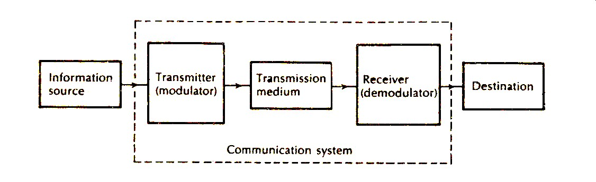
Optical Communication System:
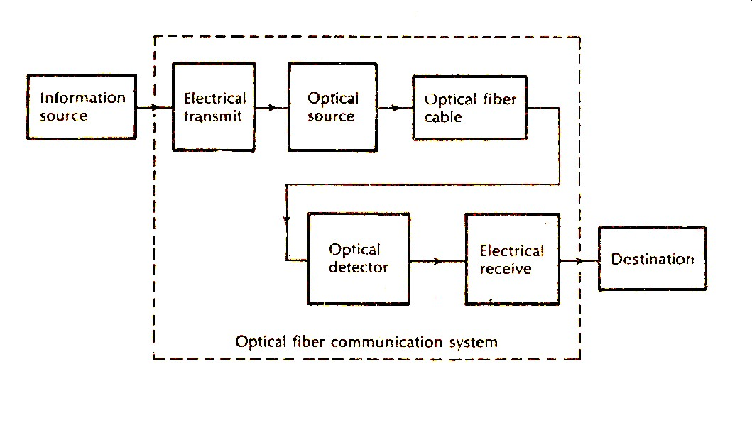

Optical Fiber:
Advantages of Optical Communication System:
- Large Bandwidth
- Small Physical Size
- Light Weight
- Electrical Isolation / Non Conductor
- Immunity to Interference
- Immunity to Cross Talk
- Signal Security
- Low Transmission Loss
- Flexibility
- Low Cost /bit(Installation , Maintenance and Bandwidth)
- High-Quality Transmission
- Environmental Stability
Disadvantages of Optical Fiber Communication:
- Expensive to install
- Dangerous for eyes
- More fragile than wire and are difficult to split

Optical Fiber System:
- PDH (Plesiochronous Digital Hierarchy)
- SDH (Synchronous Digital Hierarchy)
- DWDM (Dense Wave Division Multiplexing)

PDH (Plesiochronous Digital Hierarchy)
Plesiochronous Digital Hierarchy (PDH) is a technology used in telecommunications networks to transport large quantities of data over digital transport equipment such as fiber optic and microwave radio systems.
PDH is typically being replaced by Synchronous Digital Hierarchy (SDH) or Synchronous optical networking (SONET) equipment in most telecommunications networks.
Limitation of PDH
- Impossible to interconnect three mismatched PDH standards
- No worldwide optical interface standard
- Week Monitoring due to insufficient capacity for network management
- No direct removal of lower order signal
- Lower data rates for current and future demands

SDH (Synchronous Digital Hierarchy)
SDH is a hierarchical set of digital transport structures, the same for the transport of properly modified payloads over physical transmission networks. It is an integrated transmission network managed by a powerful network management system.
Synchronous optical networking (SONET) and synchronous digital hierarchy (SDH) are standardized multiplexing protocols that transfer multiple digital bit streams over optical fiber using lasers or light-emitting diodes (LEDs).

SDH bit rates
- STM-1: 155.52 Mbps
- STM-4: 622.08 Mbps
- STM-16: 2.488.32 Gbps
- STM-64: 9.95 Gbps
- STM-256: 40 Gbps

STM-N | Line Rate (Mb/s) | E1 Capacity | E3 Capacity | E4 Capacity
N=1 | 155.52 | 63 | 3 | 1
N=4 | 622.08 | 252 | 12 | 4
N=16 | 2488.32 | 1008 | 48 | 16
N=64 | 9953.28 | 4032 | 192 | 64
N=256 | 39813.12 | 16128 | 768 | 256

Mapping
A process used when tributaries are modified into Virtual Containers (VCs) by adding justification bits and Path Overhead (POH) information. Its real meaning is to make the various tributary signals synchronized with related virtual containers so that VC can be an independent entity in the transmission, multiplexing and cross connection.

Alignment
This process takes place when a pointer is included in a Tributary Unit (TU) or an Administrative Unit (AU), to allow the first byte of the Virtual Container to be located.
By setting the pointer, it can provide a flexible and dynamic method for alignment of VC in the unit (TU or AU-4) frame.

Multiplexing
This process is used when multiple lower-order path layer signals are adapted into a higher-order path signal, or when the higher-order path signals are adapted into a Multiplex Section.
This type of multiplexing comes under synchronous multiplexing category

Stuffing
When tributary signals are multiplexed & aligned, some spare capacity is required in SDH frames to provide space for various tributary rates
This space capacity is filled with "fixed stuffing" bits that carry no information, but are required to fill up the particular frame.

Advantages of SDH
- More Capacity
- Easy to connect different systems
- Simple and direct adding or dropping of electrical signals
- Network Management System (NMS)
- Flexible and self-healing networks (protection)
- All current PDH signals can be transmitted within the SDH except 8 Mb/s (E2) which has no container.
- A reduction in the amount of equipment & an increase in network reliability.
- Compatible….PDH, ATM, DQDB

Disadvantages of SDH
- Lower Bandwidth utilization
- Complicated SDH equipments due to variety of management traffic types and options
- Software based which is vulnerable to computer viruses, software bugs, configuration problems, etc.
- Direct add/drop needs pointer, which make it complex and introduce jitter
- Can’t carry E2 due to un-availability of container

Difference from PDH
Synchronous networking differs from Plesiochronous Digital Hierarchy (PDH) in that the exact rates that are used to transport the data on SONET/SDH are tightly synchronized across the entire network, using atomic clocks. This synchronization system allows entire inter-country networks to operate synchronously, greatly reducing the amount of buffering required between elements in the network.
DWDM (Dense Wave Division Multiplexing)
An optical technology used to increase capacity over existing fiber cables. It transmits multiple signals simultaneously at different wavelengths on the same fiber. That is one fiber is transformed into multiple virtual fibers.
Different signals with specific wavelengths are multiplexed into a fiber for transmission.

Advantages of DWDM
- Transparent transmission
- Long haul transmission
- High capacity
- Use existing optical fibers
- High performance-to-cost ratio
- Reliability
- Easy up-gradation
Self-Healing Network
It is a network which can automatically resume its loaded services within a very short time in case of fault.
Its terminal users do not notice any service interruption.
Basic Principle
The basic principle of self-healing network is when the working route fails or experience problems, services will be switched to the protecting route automatically within a very short time (<50ms).
Redundancy routes are essential for self-healing networks.

Introduction to:
- NMS OPERATIONS
- Local Networks and long-haul Networks
- NE(Network Element) - OSN(Optical Switching Node) 3500
- SDH Boards of the OSN
- Configuration of OSN
NMS OPERATIONS
- Cable loss monitoring
- Network expansion i.e. adding new Network Elements
- Configuring new services such as Ether Net, E1/T1 (2/1.5 MbPS), E3/T3 (34/45 MbPS), E4/STM-1 (140/155 MbPS) Optical/Electrical, STM4 (622 MbPS) etc.
- Back up files of the whole network and services are maintained for emergencies
- Fault location and management of remote sites where trained staff is not available
- Centralized Software up gradation (version change) of whole network.
- All major, minor and critical alarms of the network and abnormal events are monitored round the clock and analyzed
- Performance events of SDH systems i.e. Regenerator Section Background Block Error (RSBBE), Multiplex Section Background Block Error (MSBBE), Administrator Unit pointer Justification Count High (AUPJCH) etc are monitored and informed accordingly
- Services modifications i.e. cross connections are made as per plans issued by the H/Q’s/ Regional office as per requirement

Local Networks and long-haul Networks:

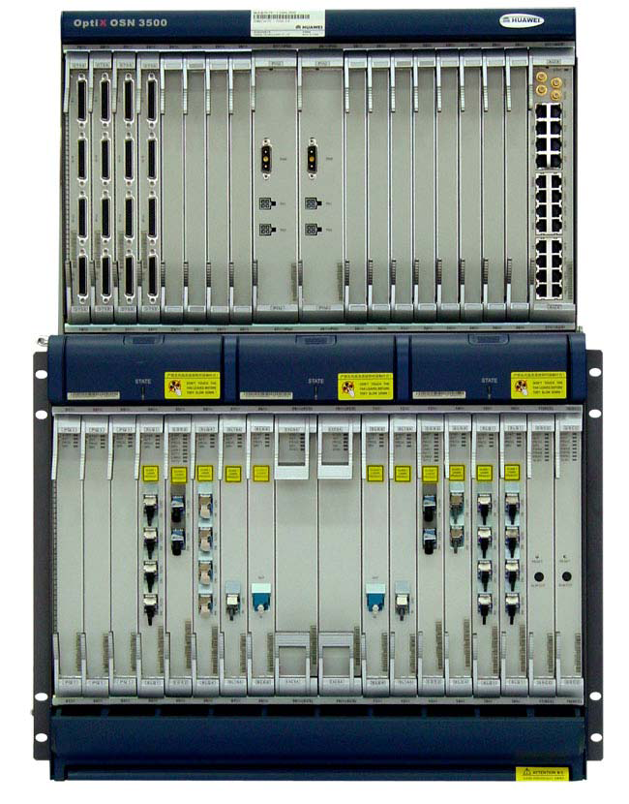
OSN3500:
Optical Switching Node has following features:
- Service level agreement (SLA)
- Topology automatic discovery function
- Automatic end-to-end service configuration
- Support mesh networking and protection
- Traffic engineering
- Supports RPR

Sub rack with Boards (OSN3500)

Slot Access Capacity
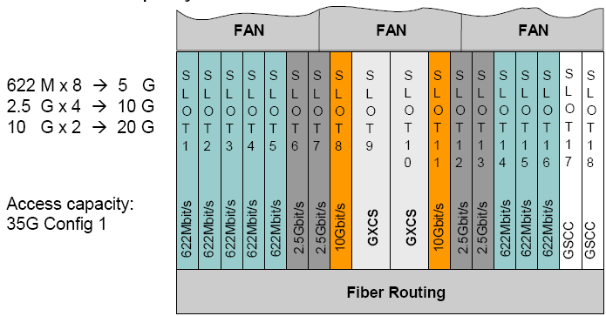
Access Capacity: 35G Config 1

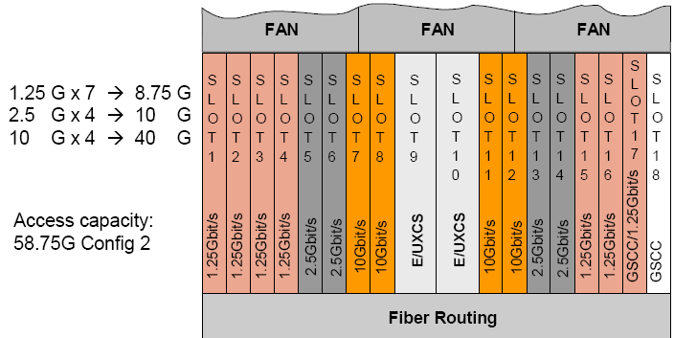
Access Capacity: 58.75G Config 2

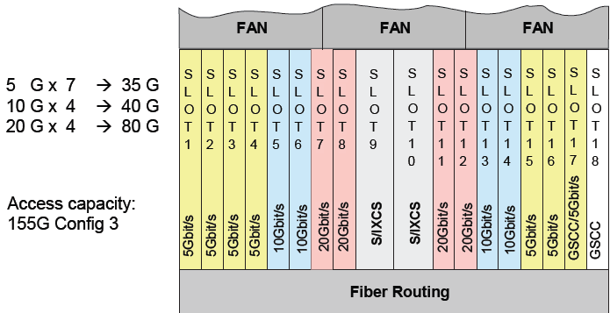
Access Capacity: 155G Config 3

SDH Boards of the OSN3500
Local Network
OSN – [1896-RWP]
D  1  2  S | D  1  2  S | D  1  2  S | D  1  2  S | D  1  2  S | D  1  2  S |  |  | P  I  U | P  I  U | D  1  2  S | D  1  2  S | D  1  2  S | D  1  2  S |  |  |  |  | A  U  X
19 20 21 22 23 24 25 26 27 28 29 30 31 32 33 34 35 36 37
F A N
F A N
F A N

P  Q  1 | P  Q  1 | P  Q  1 | P  Q  1 | N  1  S  L  Q  1 | N  1  S  L  Q  4 | D  C  U | N  2  S  L  1  6 | G  X  C  S  A | G  X  C  S  A | N  2  S  L  1  6 | N  2  E  G  S  2 | P  Q  1 | P  Q  1 |  |  |  | S  C  C
01 02 03 04 05 06 07 08 09 10 11 12 13 14 15 16 17 18

Boards:
PQ1 (tributary card): PQ1 is the 63xE1 interface board. It processes 63xE1 signals.
N1SLQ1 (line card): It is 4xSTM-1 optical interface board. It receives/transmits four channels of STM-1 optical signal.
N1SL4: it is the 1xstm-4 optical interface board. It receives/transmits one channel of STM-4 optical signal.
DCU: Dispersion compensate unit. The DCU board can compensate the optical signal dispersion accumulated during fiber transmission in the 10Gbits/s system and the optical signal is restored. It can work with the optical amplifier board for long haul optical transmission.
N2SL16: it is the STM-16 optical interface board. It receives/transmits one channel of STM-16 optical signal.
GXCSA: 40G/5G XCS board.
N2EGS (Ethernet card): 2-port gigabit Ethernet switching processing board.
SSC: it is the system control and communication board. It functions main control, communication and system power monitoring.
D12S: 32 channels 120ohm. Electrical interface switching Commutator.
PII: Power Interface Unit board. Perform power access, lightening protection and filtering functions.
Long-Haul Network
WDM-OTM
Rawalpindi-1063-IBAII 1-1 to Mandra
P M U

O  B  U | L  W  F  S | L  W  F | F  I  U | S  C  2 | S  C  C | L  W  F | L  W  F | L  B  F  S | L  B  F  S | O  A  U
01 02 03 04 05 06 07 08 09 10 11 12
OBU: The EDFA optical module of the OBU board only has an optical booster amplifier (BA) that works in the same way as OAU.
LWFS: STM-64 Transmit-receive line wavelength conversion unit with FEC function (super WDM)
LWF: the LWF board accesses STM-64 signal and transmits it with FEC (forward error connection) code and vice versa. The implementation of FEC improves the signal quality and extends the transmission distance
FIU: Fiber interface unit is located in the front of the supervisory channel board and behind the amplifier unit is WDM system. It conveys C and L bands and supervisory channels and then transmits over single strand of fiber.
SC2: It processes two supervisory channels and receive/transmits the optical signals from both directions.
SCC: System control and communication board (SCC) is the control centre of network element. It accomplishes all the management functions is responsible for communication between the equipment and network management system. It implements the order wise overhead process as well.
LBFS: transmit-receive line wavelength conversion unit for 10GE (LAN/WAN) with AFEC, super WDM.
QAU: Generally applied to erbium doped fiber amplifier (EDFA) in the WDM system. Amplifier optical signals in the fibers and compensate signals attenuation caused by optical components and fiber.

Rawalpindi-1064-IBAII 1-2 to Mandra
M  4  0 | L  B  F  S | E  T  M  X | L  B  F  S | E  T  M  X | S  C  C | D  C  P | E  T  M  X | E  T  M  X | L  W  C  1 | D  4  0
01 02 03 04 05 06 07 08 09 10 11 12 13
M40: it is 40 channels multiplexing unit
LBFS: Transmit-receive line wavelength conversion unit for 10GE (LAN/WAN) with AFEC, super WDM.
ETMX: Enhanced quadruple 2.5G transparent multiplex unit.
DCP: Double Channel protects.
LWC1: STM-16 wavelength conversion board support (G.709)
D40: it is 40 channels optical demultiplexer unit.

OPTICAL FIBER CABLE
Optical Fiber – Introduction
- An optical fiber is a dielectric wave guide that operates at optical frequencies (near & far infrared)
- It is normally cylindrical in shape
- It confines electromagnetic energy in the form of light within its surfaces and guides it in a direction parallel to its axis.
- Optical Fiber is made up of silicon dioxide
- Ge (Germanium) F (Fluorine) and B (Boron) are added to produce two similar materials having a slightly different indices of refraction for core and cladding
- Silicon (sio₂) used in Glass Fiber
- Plastic Fiber: Plastic used (core glass) or ( cladd Plastic)
- Floured Fiber: Improved type of glass fiber (Core and cladd are same Material

Optical Fiber – Structure

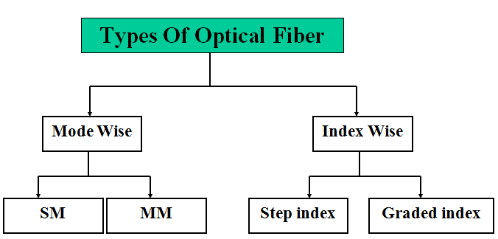

Optical Fiber – Construction

1- Core (5 to 10 micro meter dia)
2- Cladding (125 micro meter dia)
3- Jacket (250 micro meter dia)

MM Optical Fiber – Construction

1- Core (50 to 60 micro meter dia)
2- Cladding (125 micro meter dia)
3- Jacket (250 micro meter dia)

Optical Fiber Cable – Applications

- Public and Private Telecommunication Lines
- Computer network (LAN , WAN )
- Television distribution network (CATV)
- Military network (SCO)
- Control , remote control and Signalizing network
- Video supervision lines

Optical Fiber Cable – Advantages

1- Non Conductivity
No grounding is necessary because of metal free cable
2-Large Wide Bandwidth
Suitable for high speed. Wide-band, large-capacity telecommunication lines
3-Low Loss:
Because of low loss, few or no amplifiers are necessary.
4-very Light Weight:
The smallest cables can be designed and manufactured, therefore reduce pulling strength and reduce Laying cost.
5-Economics:
The most economical solution for the simultaneous transmission of servile multi channel users.
6-No cross Talk
Being non-inductive there is no induction of signal into/from other circuits so that possibility of cross talk is virtually eliminated.
7-Many channel Capacity
8-Easy installation
9-Small size

Optical Fiber Cable – Disadvantages

1-Cost
Although availability of raw material is guaranteed, the manufacture of Optical Fiber extremely difficult and involves complete set up for heat and chemical treatment of sio₂ to reach the desired purity required to producing Optical Fiber.
2-Remote Power Feeding
Power of operation of regenerators cannot be transmitted on Optical Fibre (Dielectric nature).Additional arrangements are to be made for this purpose e.g use of stand by batteries, solar power panels etc.
3-Non-Linear characteristics of Optical converters
The electrical and optical characteristics of optical converters are non-linear, which results in extra noise, loss of power, coupling efficiency of optical sources, conversion efficiency of optical devices etc.
4-Hazards with lasers
These radiations are extremely dangerous. Their exposure to eyes or skin can cause irreparable damage. Necessity of safety precautions must be taken working with the optical fiber system.

Types of Optical Fiber Cable

1- Indoor Cable
2- Rack cable (flexible, often single fiber, patch cords, and pig-tails)
3- Direct buried cable
4- Duct cable (Loose fibers in tube & Slotted core)
5- Aerial cable (Self-supporting wire)
6- Submarine cable
7- Ribbon fiber cable

O.F cable is available in three forms:
1. Slotted core cable
2. Loose tube cable
3. Loose tube slotted core cable
Optical fiber cable used in Pakistan
1. Olex cable (18 fiber slotted core number of slot 6)
2. Fujikura cable (18 fiber slotted core number slot 10)
3. Siemens cable (12 fiber loose tubes)
4. LT Engineering cable (18, 12, 6 fiber loose tube and Loose tube with slotted core)

Optical Fiber Cable – Construction

Direct buried O.F cable optical fiber construction
Direct buried O.F cable (OLEX)

10

Slotted Core
Outer PE Sheath
Armoring Wire
Middle PE Sheath
Steel Tape
Inner PE Sheath
Strength Member

Submarine Optical Fiber Cable – Construction

Fibres

Duct buried O.F cable Aerial Optical Fiber Cable Construction
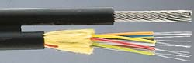

Optical Fiber Cable – Color Scheme
OLEX O.F cable
Slot No 1= White-Blue-Orange-Green
Slot No 2= White-Blue-Orange-Green
Slot No 3= White-Blue
Slot No 4= White-Blue-Orange-Green
Slot No 5= White-Blue-Orange-Green
Slot No 6= Empty
FUJIKURA O.F cable
Slot No 1 = White-Blue
Slot No 2 = White-Yellow
Slot No 3 = White-Green
Slot No 4 = White-Red
Slot No 5 = White-Violet
Slot No 6 = White-Brown
Slot No 7 = Red-Blue
Slot No 8= Red-Yellow
Slot No 9 = Red-Green
Slot No 10 = Empty
ERICSSON O.F cable
Slot No 1= White-Blue-Red-Green
Slot No 2= White-Blue-Red-Green
Slot No 3= White-Blue-Red-Green
Slot No 4= White-Blue-Red-Green
Slot No 5= White-Blue-Red-Green
Slot No 6= White-Blue-Red-Green
LT O.F cable
Tube Color = Fiber Color
Blue Blue-Orange
Orange Blue-Orange
White Brown- Orange
White Blue-Orange-Brown-Green
White Blue-Orange-Brown-Green
White Blue-Orange-Brown-Green

Cable Preparation For Joint
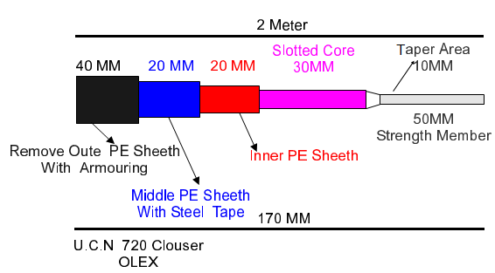

Fiber Splicing
- Introduction
- Preparation of fiber for splicing
- Mechanical splicing
- Fusion splicing
- Introduction to FSM 50S
- Practices (using FSM 50S)

We Need to Splice for
- Installation constraints , limitations, Adds, moves & changes
- Restorations and Acceptance testing

Types of Splicing
There are two main types of splicing:
1-Fusion splicing 2-Mechanical splicing
Fusion Splicing
Fusion Splicing is permanent splicing. Loss of Fusion Splicing is 0.02 to 0.05
Three main steps are involved in fusion splicing.
- Stripping: Remove the jacket with the help of stripper at the length of 4.5cm to 5cm or 45mm to 50mm.
- Cleaning: Clean the Fiber with the help of solvent (acetone) and gauze piece or tissue paper.
- Cleaving: Cleave the strip and clean Fiber with the help of cleaver at the angle of 90° and length after cleaving 20mm.
Mechanical Splicing
Mechanical Splicing is temporary splicing. Loss of Mechanical Splicing is 0.2 to 0.5.Three main steps are involved in Mechanical splicing.
1. Stripping: 45 to 50 mm 2.Cleaning with Acetone
3. Cleaving: Cleave the strip and clean Fiber with the help of cleaver at the angle of 90° and length after cleaving 10mm.
- Strip, clean & cleave
- Align it in V-groove
- Apply index matching gel
- Hold in position either by epoxy resin or by mechanical clips
- Fix the splice
Different Types of Mechanical Splice

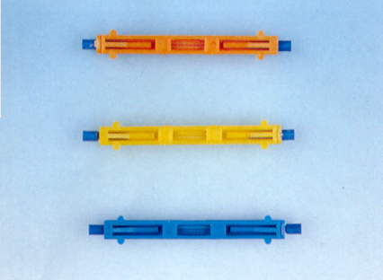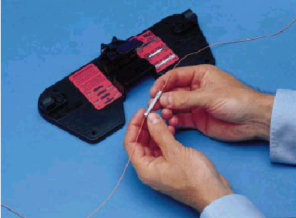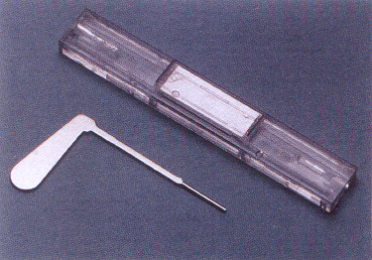
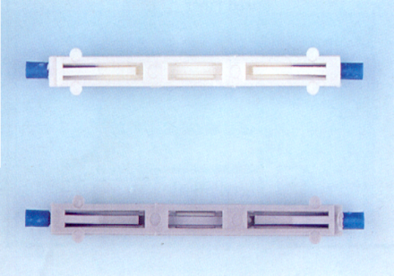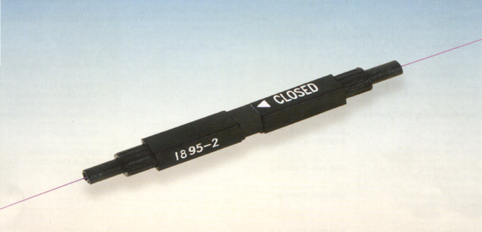

Mechanical vs. Fusion Splicing
Mechanical splice loss is 0.2 to 0.5 db.
Fusion splice loss is from 0.02 to 0.05 db.
Conclusion: Since Mechanical splice loss is ten times more than Fusion splice so Fusion splice is preferred.

Wireless Local Loop
Definition
- WLL is a system that connects the subscribers to the PSTN using radio system as a substitute for the copper for all or part of the connection between subscriber and switch.
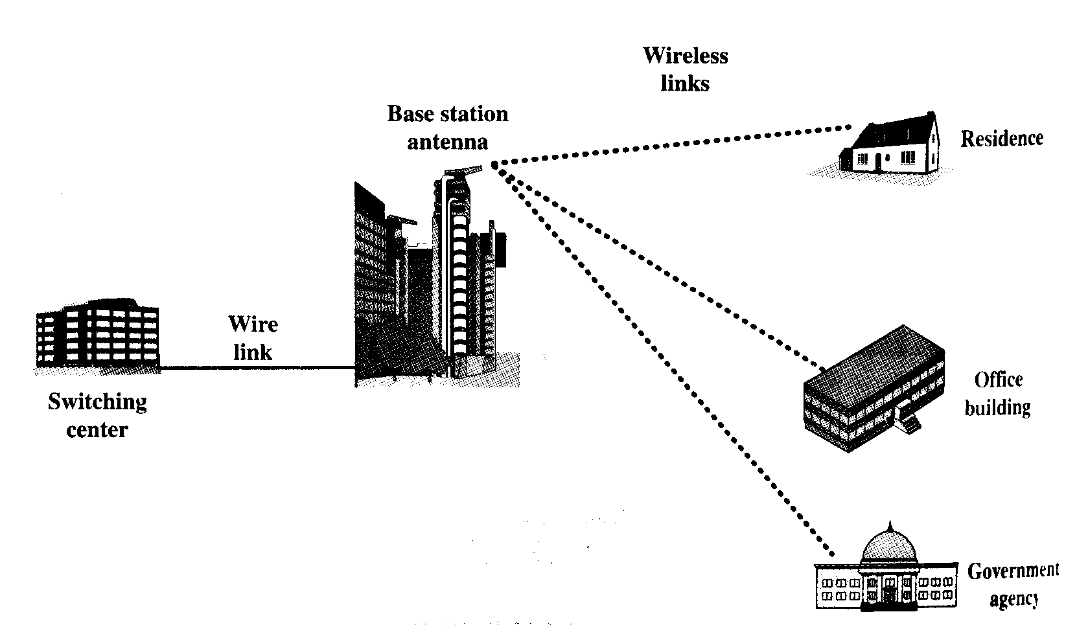
Advantages of WLL
  - Cost of installation and maintenance of WLL is lower than cable network
  - Installation time is less in case of WLL
  - Selective installation: Installation for those who require connection at a certain time
  - Quality of wireless technologies have improved to nearly equal the contemporary wired options which do face problems like longer distances in xDSL and lack of infrastructure, so WLL offers tough competition
  - Cellular systems are too expensive with lesser signal quality than fixed broadband wireless which uses directional antennas
Radio Frequency bands allocated by PTA: (1) 1.9 GHz (2) 450 MHz
Duplexing method
FDD/TDD
Frequency division duplex/Time division duplex
Coverage Radius of BTS
20 to 25 Km, extendable to double this value. Base station sensitivity is 125 dbm
Power Supply: To BTS, BSC and MSC is -48 V (-44 V - -56.4 V)
Equipment to be available at sites
- MSC: Mobile Switching center
- BSC : Base Station Controller
- BTS : Base Transceiver Station
- HLR/AuC : Home Location Register/Authentication Center

CDMA IS-95 Standard
- Introduced in: 1993
- Access Method: CDMA
- Uplink band: 869 to 894 MHz
- Downlink band: 824 to 849 MHz
- Forward rev. spacing: 45 MHz
- Channel Bandwidth: 1250 KHz
- No. of duplex channels: 20
- Max. power of mobile: 0.2 Watts
- Users per channel: 35
- Modulation: QPSK
- Carrier bit rate: 9.6 Kbps
- Frame size : 20 m sec
Error control coding: Convolutional1/2
Common Technical Terms
- Bit, Symbol, Chip:
  - A bit is the input data which contain information
  - A symbol is the output of the convolution, encoder, and the block interleaving
  - A chip is the output of spreading
- Processing Gain:
  - Processing gain is the ratio of chip rate to the bit rate.
  - The processing gain in IS-95 system is 128, about 21dB.
- Forward direction: Information path from base station to mobile station
- Reverse direction: Information path from mobile station to base station
A CDMA Network
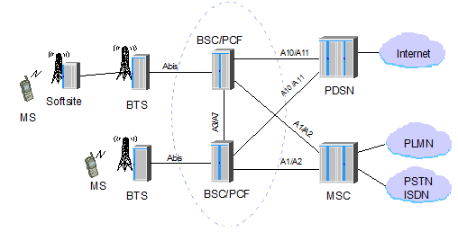

BTS: Base Transceiver Station MSC: Mobile Switching Center
BSC: Base Station Controller PDSN: Packet Data Service Node
PCF: Packet data Control Function MS: Mobile Station

WLL SYSTEM TECHNOLOGIES
1. Analog cellular
2. Digital cellular
3. Personal communications services / network (pcs/pcn)
4. Digital cordless systems
5. Proprietary implementations
Analog Cellular
- These systems use conventional FM on either 25 or 30 kHz channels in 800 or 900MHz mobile bands. Most recently AMPS operate in 1800-2000MHz band.
- Best suited to serve low or medium density markets, with long range up to 70km, with fixed units having high gain antennas.
- Narrow band analog transmission results in low speed.
- Since the access method is FDMA, the subscriber unit cannot support more than one line per radio transceiver.
- Relatively low capacity in terms of number of channels.
Digital Cellular
- Digital cellular can support higher capacity and better functionality than analog cellular and wire line networks.
- Digital cellular systems are encrypted and provide high speech security with no impact on quality.
- Both DAMPS and GSM use TDMA and support multiple lines from a single subscriber unit.
- Some of these systems have general confusion over industry standards.
- GSM currently dominates mobile cellular industry, but there has been little activity in using GSM as a WLL platform.
Personal Communications Services/ Network (PCS/PCN)
- PCS starts to operate in the 1800 MHz frequency band. PCS/PCN incorporates elements of digital cellular and cordless standards as well as newly developed RF protocols.
- Its purpose is to offer low-mobility wireless service using low-power antennas.
Digital Cordless Systems
- CT2 (Cordless telephone 2nd generation) and DECT (Digital Enhanced / European cordless telephone systems are its types.
- CT2 provides the user with a single 32kb/s duplex channel, but it has not been universally adopted.
- DECT is a picocellular wireless system for very dense subscriber environments where demand per km is high
Proprietary Implementations
- Proprietary systems like broadband CDMA and fixed radio access are designed from vendors like Interdigital, Ionica and NORTEL. Equipment providers include corporate giants such as Motorola, Ericsson, Lucent, Siemens, NEC, Qualcomm and Hughes Network Systems as well as many other smaller companies.

Next Generation Network
Introduction:
A next generation network is a packet based network that can be used for both telephony and data that support mobility. Initially, the term next generation network is used to refer to the transformation of the core network to IP. Sometime a NGN is referred to as all IP network.NGN are based on internet technologies including internet protocol and multi-protocol label switching (MPLS)
- Packet-based transfer
- Separation of control functions among bearer capabilities, call/session, and application/ service
- Decoupling of service provision from network, and provision of open interfaces
- Support for a wide range of services, applications and mechanisms based on service building blocks (including real time/ streaming/ non-real time services and multi-media)
- Broadband capabilities with end-to-end QoS and transparency
- Interworking with legacy networks via open interfaces
- Generalized mobility
- Unrestricted access by users to different service providers
- A variety of identification schemes which can be resolved to IP addresses for the purposes of routing in IP networks
- Unified service characteristics for the same service as perceived by the user
- Converged services between Fixed/Mobile
- Independence of service-related functions from underlying transport technologies
- Compliant with all Regulatory requirements, for example concerning emergency communications and security/privacy, etc.

