INTERNSHIP REPORT

Submitted By: Syed Atique Bashir
BS Telecommunication Engineering
Institute: UNIVERSITY OF MANAGEMENT AND TECHNOLOGY, LAHORE
INSTRUCTOR: Engr. KHALID SARWAR

ACKNOWLEDGMENTS

This is one step in the process of building our engineering personality. This step as everything else is possible only by Allah's will.
I wish to express deepest gratitude and sincere thanks to my supervisor Mr. KHALID SARWAR(ES NGN PTCL) for his encouragement, invaluable guidance, advice and indispensable help without which the completion of this work would not be possible. I am also very thankful to al the managers and staff members of NGN department for their co-operation in developing this project.
I appreciate the efforts and help of Mr. Maqsood(ES NGN PTCL), as his suggestions help me to understand the NGN.
I would also like to take this opportunity to express special thanks to my family for their support and patients.
I am deeply indebted to a large group of teachers, friends and colleagues, who have suggested, choose and advise me to be a member of Telecommunication technology.

Atique Bashir

Table of Contents
1 VOICE OVER IP (VoIP) ……………………………………………………………………..1
1.1 BENEFITS OF VoIP ……………………………………………………………………………………2
1.2 REQUIREMENTS FOR VoIP …………………………………………………………………………...3
1.3 PROTOCOL ………………………………………………………………………………………………………………….3
1.3.1 OSI (OPEN SYSTEM INTERCONNECTION) …………………………………………………3

2 SIGNALING …………………………………………………………………………………………………………………5
2.1 DEFINITION ………………………………………………………………………………………………………………….5
2.2 SIGNALING SYSTEM 7 …………………………………………………………………………...5
2.3 SS7 PROTOCOL STACK …………………………………………………………………………………………….6
2.3.1 DESCRIPTION OF SS7 LAYERS ……………………………………………………………………….6

3 NEXT GENERATION NETWORKS (NGN) ……………………………………………………..8
3.1 WHAT IS NGN ……………………………………………………………………………..8
3.2 DESCRIPTION ……………………………………………………………………………………………………….8
3.3 CHARACTERISTICS OF NGN ……………………………………………………………..9
3.4 ARCHITECTURE ……………………………………………………………………………………………………..10
3.4.1 ARCHITECTURE LAYERING ……………………………………………………………………..13
3.5 DESCRIPTION OF NGN LAYERS ………………………………………………………………………………..14
3.5.1 EDGE ACCESS …………………………………………………………………………………………..14
3.5.2 CORE SWITCHING …………………………………………………………………………………………..14
3.5.3 NETWORK CONTROL ………………………………………………………………………………..14
3.5.4 SERVICE MANAGEMENT ………………………………………………………………………………..14
3.6 PROTOCOL USED IN NGN ……………………………………………………………………15
3.7 NGN-ENABLED SWITCH APPLICATIONS ……………………………………………………………………..16
3.8 NETWORK COMPONENTS …………………………………………………………………………………………..16
3.8.1 CALL AGENT\SIP SERVER\SIP CLIENT …………………………………………………………..16
3.8.2 SERVICE BROKER …………………………………………………………………………………………..17
3.8.3 APPLICATION SERVER ………………………………………………………………………………..17
3.8.4 MEDIA SERVER …………………………………………………………………………………………..17
3.8.5 SIGNALING GATEWAY ………………………………………………………………………………..17
3.8.6 TRUNKING GATEWAY ………………………………………………………………………………..17
3.8.7 ACCESS GATEWAY ………………………………………………………………………………..18
3.8.8 ACCESS CONCENTRATOR ……………………………………………………………………..18
3.8.9 BANDWIDTH MANAGER ………………………………………………………………………………..18
3.8.10 EDGE ROUTER …………………………………………………………………………………………..18
3.8.11 SUBSCRIBER GATEWAY ………………………………………………………………………………..18
3.8.12 BRIDGE\ROUTER ………………………………………………………………………………..18
3.8.13 IP PHONE\PBX ……………………………………………………………………19
3.9 HUAWEI NGN ……………………………………………………………………………19

4 SOFTSWITCH ……………………………………………………………………………..…………………………………20
4.1 SS (SOFTX3000) ……………………………………………………………………………20
4.1.1 INTRODUCTION …………………………………………………………………………………………..20
4.1.2 SPECIFICATION AND SUMMERY ……………………………………………………………………..21
4.2 LOCATION OF SOFTSWITCH …………………………………………………………………………………………..22
4.3 SOFTX3000 BOARDS AND THEIR FUNCTIONS ……………………………………………23
4.4 SERVICES ………………………………………………………………………………………………………………..27
4.5 FUNCTIONS ……………………………………………………………………………………27
4.6 SYSTEM CAPACITY ……………………………………………………………………………………………………..27
4.7 BILL PROCESSING CAPABILITY ………………………………………………………………………………..27
4.8 PROTOCOL PROCESSING CAPABILITY ……………………………………………………………………..28
4.9 SUMMERY ………………………………………………………………………………………………………………..28

5 SUMMERY ………………………………………………………………………………………………………………..29
5.1 WHY ARE NGNs IMPORTANT ………………………………………………………………………………..29
5.2 ISSUES IN A VoIP NETWORK ………………………………………………………………………………..31
5.3 CONCLUSION ……………………………………………………………………………………………………..32

CHAPTER 1

VoIP
- Over view of Voice over IP (VoIP)
Voice over Internet Protocol (VoIP) is a general term for a family of transmission technologies for delivery of voice communications over IP networks such as the Internet or other packet-switched networks.
Other terms frequently encountered and synonymous with VoIP are IP telephony, Internet telephony, voice over broadband (VoBB), broadband telephony, and broadband phone.
VoIP systems usually interface with the traditional public switched telephone network (PSTN) to allow for transparent phone communications worldwide. In carrier networks VoIP has been mainlydeployed in enterprise networks or as a trunking technology to reduce transport costs in voice backbone networks.
The following issues must be addressed in order to deploy a VoIP network:
- What services need to be offered, for example full PSTN equivalence, a more restricted “cheap second line” service, or a simple user-to-user voice service.
- The types of end user terminals supported – POTS phones, PC clients, IP Phones or PBXs.
- Quality of Service requirement for voice to ensure that the agreed quality is provided.
- The security risks must be clearly identified and appropriate techniques employed to ensure that the call agents, in particular, are protected from attack.
- How much bandwidth is available in the last mile network, which will affect the choice of voice
- Codec, packetization period, and where to use compression to best meet the service goals.
- The signaling protocol used must support the service set required.
- Lawful interception requirements in many countries could prevent a public carrier from allowing direct connection between IP phones. All calls may need to be routed via an access gateway that hides any intercepts in place.

  - Benefits of VoIP
- IP-based internet applications, such as email and unified messaging, may be seamlessly integrated with voice applications
- IP Centrex services allow network operators to provide companies with cost effective replacements for their ageing PBX infrastructure
- VoIP services can be expanded to support multimedia applications, opening up the possibility of cost effective video conferencing, video streaming, gaming or other multi-media applications.
- The flexibility of next generation platforms allows for the rapid development of new services and development cycles are typically shorter than for ATM or TDM-based equipment.
- The ability to transmit more than one telephone call over the same broadband connection.
- Secure calls using standardized protocols (such as Secure Real-time Transport Protocol.) Most of the difficulties of creating a secure phone connection over traditional phone lines, like digitizing and digital transmission, are already in place with VoIP. It is only necessary to encrypt and authenticate the existing data stream.
- VoIP products based on the MSF architecture, unlike legacy TDM switches, often support open service creation environments that allow third party developers to invent and deliver differentiated services.
- Third parties may develop applications and services for end users on open architecture CPE devices such as PCs. By co-operating with such third parties network operators stand to gain increased revenues from the explosion of innovative services that this advance is likely to trigger. In addition the consolidation of voice and data in one network can significantly reduces cost.
- VoIP leverages data network capacity removing the requirement to operate separate voice and data networks.
- IP equipment is typically faster and cheaper than ATM or TDM-based equipment – a gap that is increasing rapidly every few months.
- Re-routing of IP networks (e.g. with MPLS) is much cheaper than, say, SDH protection switching.
- Routing phone calls over existing data networks to avoid the need for separate voice and data networks.
- Conference calling, IVR, call forwarding, automatic redial, and caller ID features that traditional telecommunication companies normally charge extra for are available for free from open source VoIP implementations such as Asterisk.

  - Requirements for VoIP
Whatever the justifications, most service providers recognize that VoIP is the direction of the future-however when looking at a future PSTN scale solution service providers must ensure that the following key requirements are met to provide equivalence with the PSTN:

- · Security
- · Quality of Service
- · Reliability
- · Migration path
- · OSS support
- · Billing
- · Network Interconnection

These issues are by no means simple and in many cases have delayed roll out of VoIP services. This white paper will look in more detail at these problems and consider at a high level how they might be addressed.
1.3 Protocol
It is a set of rules governing the exchange of data between two entities.
1.3.1 OSI (Open Systems Interconnection)
OSI (Open Systems Interconnection) is a standard description or "reference model" for how messages should be transmitted between any two points in a telecommunication network.
Its purpose is to guide product implementors so that their products will consistently work with other products. The reference model defines seven layers of functions that take place at each end of a communication.
LAYER NO | NAME | PURPOSE
LAYER 7 | Application | Network process to application
LAYER 6 | Presentation | Data representation and encryption
LAYER 5 | Session | Interhost communication
LAYER 4 | Transport | End-to-end connections and reliability
LAYER 3 | Network | Path determination and logical addressing
LAYER 2 | Data Link | Physical addressing (Access to Media)
LAYER 1 | Physical | Media, signal and binary transmission

OSI (Open Systems Interconnection Reference Model)
Figure 1.1
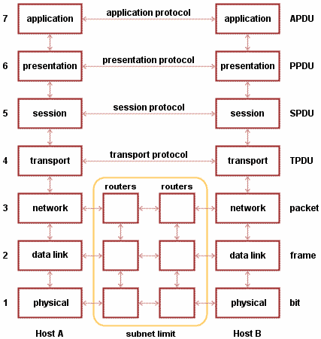
Figure 1.2
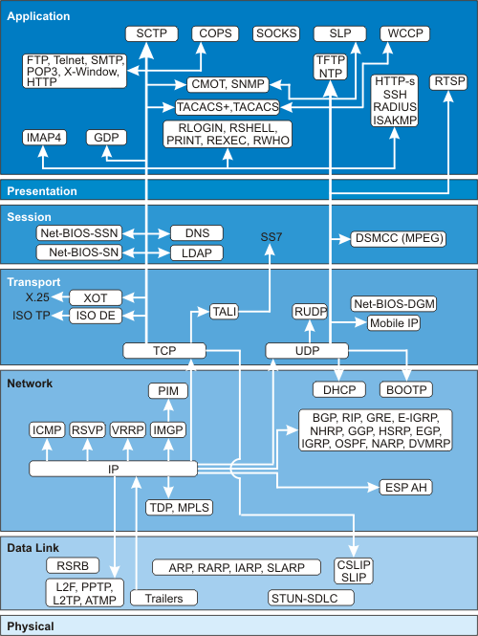

Chapter 2

Signaling

2.1 Definitions:
Signaling means the passing of information and instructions from one point to another relevant to the setting up and supervision of a telephone call.
Signaling has been divided into two types:

Subscriber Signaling:- Signaling between a subscriber terminal (telephone) and the local exchange.

Trunk Signaling: - Signaling between exchanges.

2.2 Signaling System 7

On the public switched telephone network (PSTN), Signaling System 7 (SS7) is a system that puts the information required to set up and manage telephone calls in a separate network rather than within the same network that the telephone call is made on.

OR

The process of generating and exchanging information between components of a telecommunications system.
A signaling system 7 SS7 is a set of telephony signaling protocols which are used to set up most of the world's public switched telephone network telephone calls. The main purpose is to set up and tear down telephone calls. Other uses include number translation, prepaid billing mechanisms, short message service (SMS), and a variety of other mass market services. Signaling System 7 (SS7) is architecture for performing out-of-band signaling in support of the call-establishment, billing, routing and information-exchange functions of the public switched telephone network (PSTN) or public land mobile network (PLMN). It identifies functions to be performed by a signaling-system network and a protocol to enable their performance.

2.3 SS7 Protocol Stack

Figure 2.1
The OSI Reference Model and the SS7 Protocol Stack

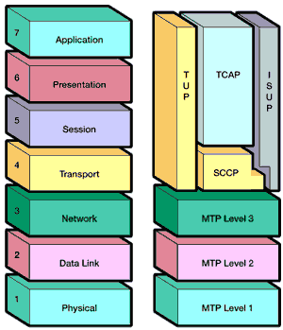

Description of SS7 layers

Message Transfer Part
The Message Transfer Part (MTP) is divided into three levels. The lowest level,

MTP Level 1
Is equivalent to the OSI Physical Layer. MTP Level 1 defines the physical, electrical, and functional characteristics of the digital signaling link. Physical interfaces defined include E-1 (2048 kb/s; 32 64 kb/s channels), DS-1 (1544 kb/s; 24 64kb/s channels), V.35 (64 kb/s), DS-0 (64 kb/s), and DS-0A (56 kb/s).

MTP Level 2
Ensures accurate end-to-end transmission of a message across a signaling link. Level 2 implements flow control, message sequence validation, and error checking. When an error occurs on a signaling link, the message (or set of messages) is retransmitted. MTP Level 2 is equivalent to the OSI Data Link Layer.

MTP Level 3
provides message routing between signaling points in the SS7 network. MTP Level 3 re-routes traffic away from failed links and signaling points and controls traffic when congestion occurs. MTP Level 3 is equivalent to the OSI Network Layer.

ISDN User Part (ISUP)
The ISDN User Part (ISUP) defines the protocol used to set-up, manage, and release trunk circuits that carry voice and data between terminating line exchanges (e.g., between a calling party and a called party). ISUP is used for both ISDN and non-ISDN calls. However, calls that originate and terminate at the same switch do not use ISUP signaling.

Telephone User Part (TUP)
In some parts of the world (e.g., China, Brazil), the Telephone User Part (TUP) is used to support basic call setup and tear-down. TUP handles analog circuits only. In many countries, ISUP has replaced TUP for call management.

Signaling Connection Control Part (SCCP)
SCCP provides connectionless and connection-oriented network services and global title translation (GTT) capabilities above MTP Level 3. A global title is an address (e.g., a dialed 800 number, calling card number, or mobile subscriber identification number) which is translated by SCCP into a destination point code and subsystem number. A subsystem number uniquely identifies an application at the destination signaling point. SCCP is used as the transport layer for TCAP-based services.

Transaction Capabilities Applications Part (TCAP)
TCAP supports the exchange of non-circuit related data between applications across the SS7 network using the SCCP connectionless service. Queries and responses sent between SSPs and SCPs are carried in TCAP messages. For example, an SSP sends a TCAP query to determine the routing number associated with a dialed 800/888 number and to check the personal identification number (PIN) of a calling card user. In mobile networks (IS-41 and GSM), TCAP carries Mobile Application Part (MAP) messages sent between mobile switches and databases to support user authentication, equipment identification, and roaming.

Operations, Maintenance and Administration Part (OMAP) and ASE
OMAP and ASE are areas for future definition. Presently, OMAP services may be used to verify network routing databases and to diagnose link problems.

CHAPTER 3

Next Generation Network (NGN)
3.1 What is NGN: The Next-Generation Network seamlessly blends the public switched telephone network (PSTN) and the public switched data network (PSDN), creating a single multiservice network.
Next Generation Networking (NGN) is a broad term to describe some key architectural evolutions in telecommunication core and access networks.
The general idea behind NGN is that one network transports all information and services (voice, data, and all sorts of media such as video) by encapsulating these into packets, like it is on the Internet. NGNs are commonly built around the Internet Protocol, and therefore the term "all-IP" is also sometimes used to describe the transformation towards NGN.
NGN is a kind of Brand-new network integrating voice, data, fax, and video services. It is an open and integrated network architecture.

- Next Generation Network (NGN) is a service-oriented network.
- Through the separation of service and call control, as well as call control and bearer, the service-independent architecture is implemented, which makes services independent of network.
- Independent network control layer
- NGN is a kind of open and integrated network architecture.
- NGN is a kind of brand-new network integrating voice, data, fax, and video services.
- NGN is based on standard protocols and packet switching network.

3.2 Description:
A Next Generation Network (NGN) is a packet-based network able to provide services including Telecommunication Services and able to make use of multiple broadband, QoS-enabled transport technologies and in which service-related functions are independent from underlying transport-related technologies. It offers unrestricted access by users to different service providers. It supports generalized mobility which will allow consistent and ubiquitous provision of services to users.
From a practical perspective, NGN involves three main architectural changes that need to be looked at separately:
- In the core network, NGN implies a consolidation of several (dedicated or overlay) transport networks each historically built for a different service into one core transport network (often based on IP and Ethernet). It implies amongst others the migration of voice from a circuit-switched architecture (PSTN) to VoIP, and also migration of legacy services such as X.25, Frame Relay (either commercial migration of the customer to a new service like IP VPN, or technical emigration by emulation of the "legacy service" on the NGN).
- In the wired access network, NGN implies the migration from the "dual" legacy voice next to xDSL setup in the local exchanges to a converged setup in which the DSLAMs integrate voice ports or VoIP, allowing to remove the voice switching infrastructure from the exchange.
- In cable access network, NGN convergence implies migration of constant bit rate voice to CableLabs PacketCable standards that provide VoIP and SIP services. Both services ride over DOCSIS as the cable data layer standard.

- In an NGN, there is a more defined separation between the transport (connectivity) portion of the network and the services that run on top of that transport. This means that whenever a provider wants to enable a new service, they can do so by defining it directly at the service layer without considering the transport layer - i.e. services are independent of transport details. Increasingly applications, including voice, will tend to be independent of the access network (de-layering of network and applications) and will reside more on end-user devices (phone, PC, Set-top box).

3.3 Characteristics of NGN
- Open and distributed network architecture
- NGN adopts the hierarchical architecture, which is divided into media access layer, transport layer, control layer and service/application layer.
- Independent network control layer
- Internetworking and gateways
- NGN is based on standard protocols and packet switching network.

3.4 Architecture

Figure 3.1

VoIP Next-Generation Network Architecture
Edge Access
Core Switch
Network Control
Service Management

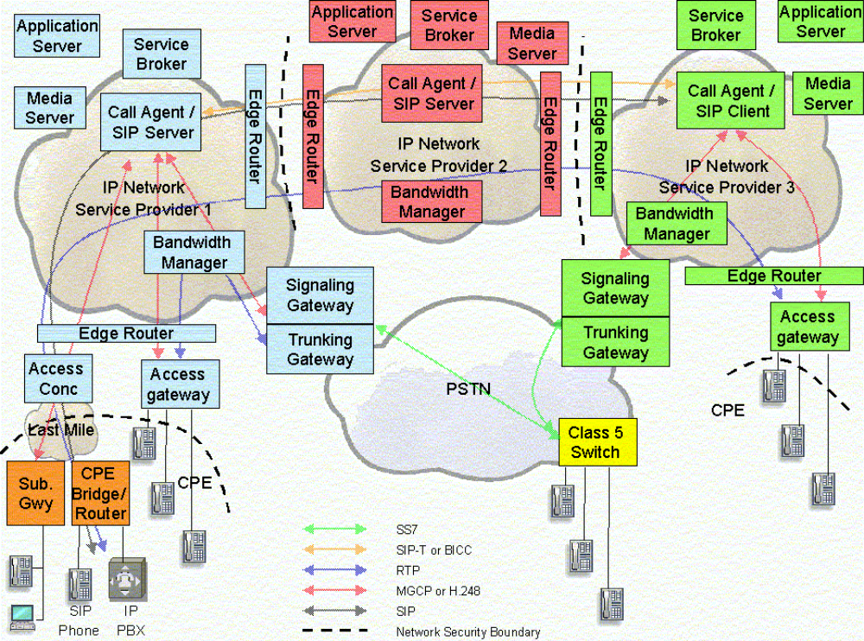

Figure 3.2
Next Generation VoIP Network
Figure 3.2 shows an example VoIP Next Generation network with 3 service provider networks.
- Service Provider 1 is offering local access acting as a LEC. This Service Provider supports IP
- phones and IP PBX systems using SIP and POTS phones via either an Access Gateway (Next Gen DLC) or a Subscriber Gateway (using either H.248 or MGCP).
- Service Provider 2 is acting as an inter-exchange carrier (IXC) and supports SIP and SIP-T or BICC signaling through its network.
- Service Provider 3 is offering local access acting as a LEC, but only supports POTS phones using an Access Gateway.
- SIP signaling is supported but is terminated by the SIP Server rather than using a SIP Phone or other CPE device.

Figure 3.3
NGN Network Architecture


IAD
AMG
BroadBand
Access
UMG
PLMN/3G
SG
TMG
PSTN
UMG
Service Management
Packet Core Network
Network Control
Core Switching
Edge Access
SoftSwitch
SoftSwitch
iOSS
Policy
Server
SCP
MRS
Many existing applications were developed in a “stovepipe” fashion, hard-coded for a specific type of transport. For carriers wishing to support a limited set of applications over a limited number of transport mechanisms, this strategy is adequate. This “stovepipe” approach might provide better performance and reliability but as the number of applications and types of transport increase, the “stovepipe” approach can become quite inefficient.
Therefore, one of the primary goals of NGN is to provide a common, unified and flexible control environment that can support multiple types of services and management applications over multiple types of transport.

Figure 3.4
Next Generation Control
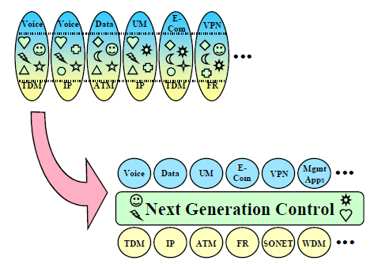
3.4.1 Architectural Layering:
The concept of architectural layering is central to NGN environment. First and foremost, NGN cleanly separate service/session control from underlying transport elements. This allows carriers to choose the “best-in-breed” transport elements independent from the “best-in-breed” control software. NGN control can then be decomposed into feature control, service/session control and connectivity control. The clean separation between access, service and communication session control within the Service Layer allows each type of session to be treated independently from the other.
Figure 3.5
Architecture Layering/Open Service Interface
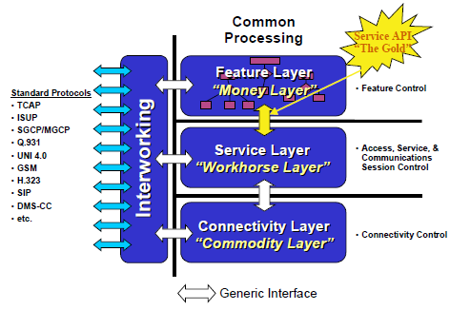

  - Description of NGN layers

3.5.1 Edge Access
This layer is divided into three parts.
- Broad Band access:-
Broad Band devices are
  - IAD (Integrated Access Device)
  - AMG (Access Media Gateway)

- PSTN
PSTN Devices are
  - SG (signaling Gateway)
  - TMG (Trunk Media Gateway)
  - UMG (Universal Media Gateway)

- PLMN/3G
PLMN/3G Devices are
  - UMG (Universal Media Gateway)

Core Switching
Core Switching Layer contains clouds of networks, giving connectivity to between soft switch and components of edge access layer by using a set of appropriate protocol.

Network Control
Network control layer consists of core of the whole NGN the SOFT SWITCH.

Service Management
This layer consists of applications programs. e.g.
- iOSS
- Policy Server
- MRS
- SCP

3.6 Protocol Used in NGN
NGN operates on a numbers of will known protocol for its efficient communication and security.
- MTP3
- ISUP
- INAP
- MGCP
- H.248
- H.323
- SIP
- R2
- Digital signaling system No.1 (DSS1)
- UDP
- SCTP
- MTP layer-2 user adaptation (M2UA)
- V5UA
- IUA
- TCP
- H.323 (including H.323 RAS and H.323 Call Signaling)
- SIGTRAN

Figure 3.6
Protocol Interconnection in NGN devices
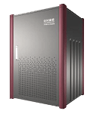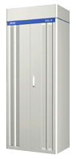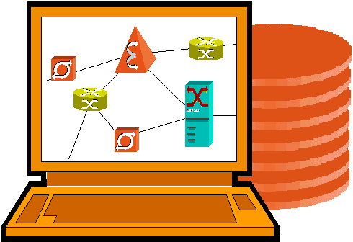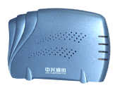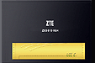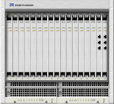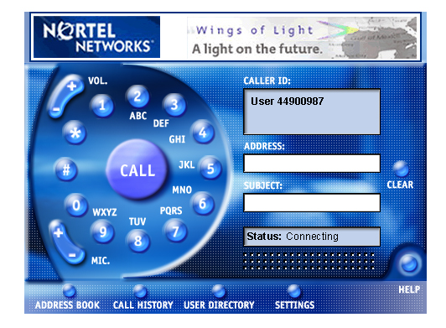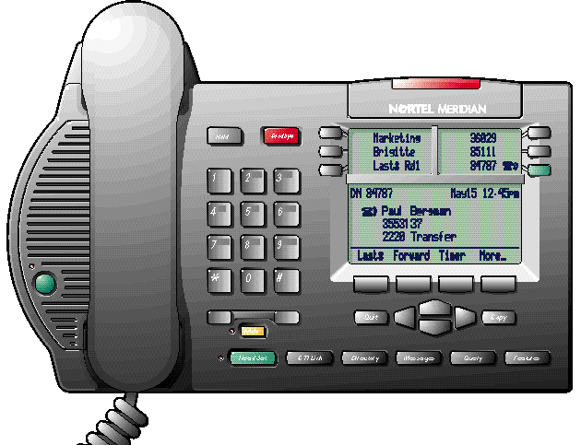
OSS
H.248
Open Service
Application Server
NMS
Softswitch
Router Server
intelligent terminal
AG
IAD
TG
SG
INAP
LDAP/TRIP
XML/FTP/Radius
Parlay
SIP
SNMP
SIP-T,Sigtran
H.323
H.323/MGCP/H.248/SIP
Sigtran
H.248
TUP/ISUP
SS7
IN
PSTN
Other
Hl323 Network
H.323 VOIP Network
Other
Hl323 Network
Other Softswitch Network
H.248

3.7 NGN-enabled Switch application
Current PSTN is narrow-band TDM circuit-switch network. In order to evolve to NGN and also take into account the evolution requirement of current network,
U-SYS solution (SoftX3000+UMG8900) implements the traditional switching functions based on NGN technology. SoftX3000 implements the soft switch function and UMG8900 implements the user access and switch function.
Through this way it can reconstruct the PSTN step by step on the basis of being compatible with the current TDM interface to implement the smooth evolution to NGN.
Figure 3.7
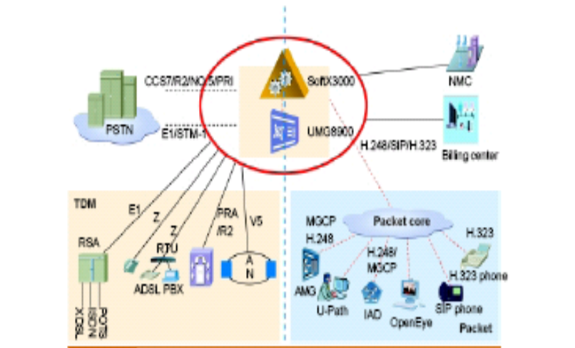

3.8 Network Components
This section describes the function of the network components listed in Figure 3.2
3.8.1 Call Agent/SIP Server/SIP Client
The Call Agent/SIP Server/SIP Client is located in the service provider’s network and provides call logic and call control functions, typically maintaining call state for every call in the network. Many call agents include service logic for supplementary services, e.g. Caller ID, Call Waiting, and also interact with application servers to supply services that are not directly hosted on call agent. The Call Agent will participate in signaling and device control flows originating, terminating or forwarding messages.

3.8.2 Service Broker
The service broker is located on the edge of the service providers service network and provides the service distribution, coordination, and control between application servers, media servers, call agents, and services that may exist on alternate technologies (i.e. Parlay Gateways and SCP s). The service broker allows a consistent repeatable approach for controlling applications in conjunction with their service data and media resources to enable services to allow services to be reused with other services to create new value added services.

3.8.3 Application Server
The Application Server is located in the service provider’s network and provides the service logic and execution for one or more applications or services that are not directly hosted on the Call Agent. For example, it may provide voice mail or conference calling facilities. Typically the Call Agent will route calls to the appropriate application server when a service is invoked that the Call Agent cannot itself support.

3.8.4 Media Server
This Media Server is located in the service provider’s network. It is also referred to as an announcement server. For voice services, it uses a control protocol, such as H.248 (Megaco) or MGCP, under the control of the call agent or application server. Some of the functions the Media Server can provide are

- playing announcements
- mixing – providing support for 3-way calling etc
- codec transcoding and voice activity detection
- tone detection and generation
- interactive voice response (IVR) processing
- fax processing
3.8.5 Signaling Gateway
The Signaling Gateway is located in the service provider’s network and acts as a gateway between the call agent signaling and the SS7-based PSTN. It can also be used as a signaling gateway between different packetbased carrier domains. It may provide signaling translation, for example between SIP and SS7 or simply signaling transport conversion e.g. SS7 over IP to SS7 over TDM.

3.8.6 Trunking Gateway
The Trunking Gateway is located in the service provider’s network and as a gateway between the carrier IP network and the TDM (Time Division Multiplexing)-based PSTN. It provides transcoding from the packetbased voice, VoIP onto a TDM network. Typically, it is under the control of the Call Agent / Media Gateway Controller through a device control protocol such as H.248 (Megaco) or MGCP.

3.8.7 Access Gateway
The Access Gateway is located in the service provider’s network. It provides support for POTS phones and typically, it is under the control of the Call Agent / Media Gateway Controller through a device control protocol such as H.248 (Megaco) or MGCP.

3.8.8 Access Concentrator
The Access Concentrator is located in the service provider’s network and terminates the service provider end of the WAN links used over the “last mile”. For example, in a DSL network, this is a DSLAM; in a cable network, a CMTS.
The Access Concentrator may also include the Access Gateway function, for example a Next-Generation DLC that combines DSLAM capability with direct POTS termination.

3.8.9 Bandwidth Manager
The Bandwidth Manager is located in the service provider’s network and is responsible for providing the required QoS from the network. It is responsible for the setting up and tearing down of bandwidth within the network and for controlling the access of individual calls to this bandwidth. It is responsible for installing the appropriate policy in edge routers to police the media flows on a per call basis.

3.8.10 Edge Router
The Edge Router is located in the service provider’s network and routes IP traffic onto the carrier backbone network. Typically the edge router will provide many other functions and can be combined with the Access Concentrator.

3.8.11 Subscriber Gateway
The Subscriber Gateway is located at the customer premises and terminates the WAN (Wide Area Network) link (DSL, T1, fixed wireless, cable etc) at the customer premises and typically provides both voice ports and data connectivity. Usually, it uses a device control protocol, such as H.248 (Megaco) or MGCP/NCS, under the control of the Call Agent. It provides similar function to the Access Gateway but typically supports many fewer voice ports.
Subscriber Gateways are also known as IADs, Residential Gateways, or MTAs (in a cable network).
3.8.12 Bridge/Router
The Bridge/Router is located at the customer premises and terminates the WAN (Wide Area Network) link (DSL, T1, fixed wireless, cable etc) at the customer premises. The difference between this and the Subscriber Gateway is a bridge/router does not provide any native voice support, although voice services for example SIP phones, can be bridged/routed via this device.

3.8.13 IP Phone/PBX
IP Phones and PBX systems are located at customer premises and provide voice services. They interact with the Call Agent/SIP Server using a signaling protocol such as SIP, H.323 or a device control protocol such as H.248 (Megaco) or MGCP.

3.9 Huawei NGN consists of
- S.S Soft Switch
- MRS Media Resources Server
- SG Signaling Gateway
- MG Media Gateway
- UMG Universal Media Gateway
- IAD Integrated Access Device
- TMG Trunk Media Gateway
- AMG Access Media Gateway

CHAPTER 4
Softswitch
  - S.S(SoftX3000)

    - Introduction:
SoftX3000 is applicable to the network control layer of NGN and implements call control and connection management of voice, data and multimedia services based on the IP network.
Figure 4.1
SoftX3000
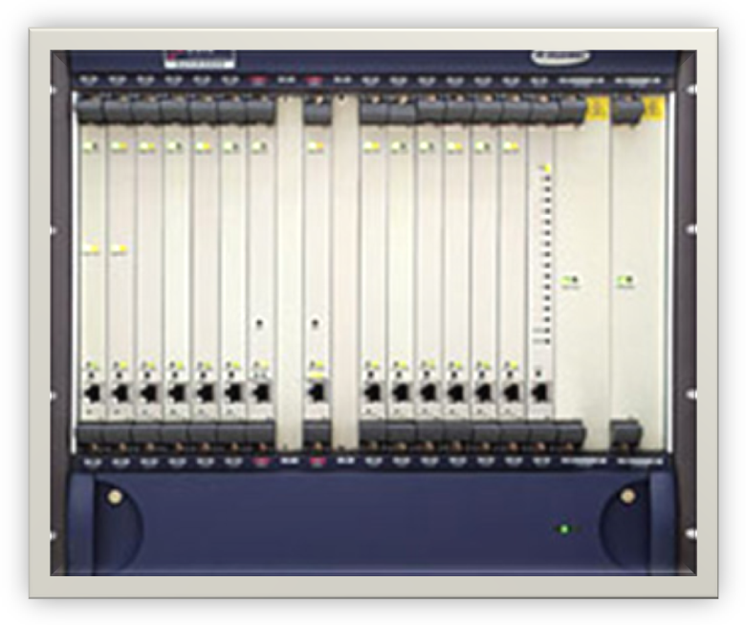
Process capacity: 16Million BHCA, 2 million subscribers/360000 trunks

4.1.2 Specifications and Summery:

- Rack specifications: 600*800*2200mm (W*D*H).
- Process capacity: 16Million BHCA, 2Million subscribers/360000 trunks.
- Carrier class reliability design: 1+1 redundancy for major components, online software patching, hot swappable and Availability: 99.99983%.
- Protocol supported: H.248/MGCP,SIP/SIP-T,H.323,
- BICC,M2UA, M3UA, IUA, V5UA, RADIUS, SS7,
- R2, PRA and INAP.
- Built-in SG and MRS (Media resource server).
- Built-in SSP with CS2 capability.
- Class 4 application with gateway functions such as authentication, charging, black/white list and equal access.
- Class 5 applications with PSTN, IN and value-added services.
- IP Centrex and multi-media services.
- Multi-area code.
- 3rd party API support based on SIP and PARLAY.
- Dual homing.
- Carrier-class reliability design
- Supports abundant protocols for example H.248/MGCP, SIP/SIP-T, H.323, etc.
- Built-in SSP
- Single platform with various applications: Class 4/Class 5/IP Centrex, etc.
- Multi-area code
- Dual homing

  - Location of Soft Switch:
Figure 4.2
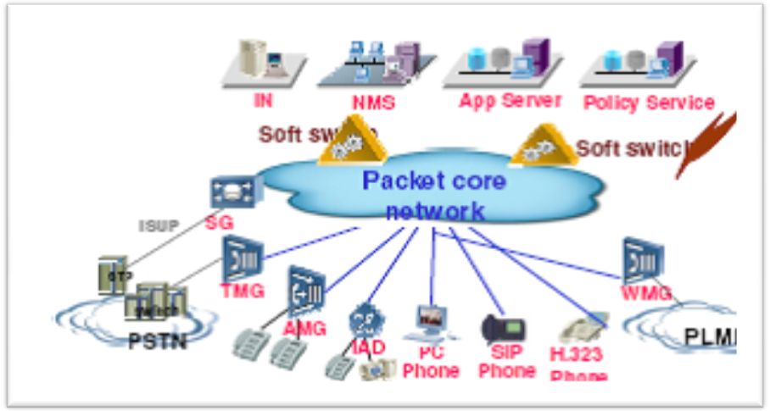
- SoftX3000 is fully compatible with all service capabilities of PSTN exchanges and can be used as a multimedia end office.
- SoftX3000 supports the traditional PSTN signaling, such as SS7, R2, DSS1 and V5. SoftX3000 can function as a voice end office, tandem office or toll office.
- SoftX3000 supports black and white lists, call authentication, call interception, and so on. SoftX3000 can act as a gateway office.
- SoftX3000 supports MTP and M3UA, which enables SoftX3000 to serve as an integrated signaling gateway.
- SoftX3000 supports INAP and INAP+, so it can be used as an SSP or IPSSP in the IN system.
- SoftX3000 supports the H.323 protocol and can function as a gatekeeper (GK) in the traditional Voice over IP (VoIP) network.

  - SoftX3000 Boards and their functions:
Board | Frame And Function | Position | Corresponding Front or Back Board
FCCU  The Fixed Calling Control Unit | Basic frame and expansion frame  The FCCU generates and stores bills in its bill pool. Each FCCU can store a maximum of 160,000 bills. The generated bills are transmitted to iGWB in real time.  The alarm information generated by the FCCU is reported to the SMUI through the shared resource bus. | Front board | None
FCSU  Fixed Calling Control and Signaling process Uni | Basic frame and expansion frame  The FCSU generates and stores bills in its bill pool. Each FCSU can store up to 160,000 bills. The detailed bills are transmitted to iGWB through the shared resource bus for processing. | Front board | Used  in  Paris
EPII  E1_Pool Interface Unit | Basic frame and expansion frame  - Processing messages on MTP1 physical layer.  - Providing narrowband signaling physical interfaces for the FCSU. The EPII is configured in pair with FCSU.  - Implementing transfer of system clock and enabling clock synchronization function in a frame.  Working with the front board FCSU to perform switchover between active and standby boards through H.110 bus. | Back board | Used  in  Paris
IFMI  IP Forward Module | Basic frame  It is used together with the back board PFII in pairs. The IFMI is used to receive and transmit IP packets, process Media Access Control (MAC) layer messages, distribute IP messages and provide IP interfaces together with the BFII. | Front board | Used  in  Paris
BFII  Back insert FE Interface Unit | Basic frame  It is used to implement FE driver processing and enable the external physical interface of the IFMI. The BFII is configured in pair with IFMI.  The BFIIs work in active/standby mode. | Back board | Used  in  Paris
SMUI  The System Management Unit | Basic frame and expansion frame  - Configuring shared resource buses and managing their status.  - Managing all boards in the frame, reporting their status to BAM and controlling the status of the indicators on the front panel of the ALUI through serial port bus and shared resource bus.  - Loading and managing system program and data.  The SMUIs work in active/standby mode. | Front board | Used  in  Paris
SIUI  System Interface Unit | Basic frame and expansion frame  - Providing the SMUI with Ethernet interface. The SIUI is configured correspondingly to the SMUI one by one.  - Implementing level conversion for two asynchronous serial port signals from the front board, and providing physical interfaces for three asynchronous serial ports.  - Identifying frame ID through setting the DIP switches.  The SIUIs work in active/standby mode. | Back board | Used  in  Paris
MRCA Media Resource Control Unit | Media resource frame  Each MRCA can function as independent media resource server. The MRCA processes the audio signals in real time. It collects and generates DTMF signals, plays and records audio clips and provides multi-party conference function.  The MRCAs work in load sharing mode. | Front board | Used  in  Paris
MRIA  Media Resource Interface Unit | Media resource frame  Is the back board of the MRCA, providing 10/100-Mbps interface for the external media streams. | Back board | Used  in  Paris
BSGI  Broadband Signaling Gateway | Basic frame and expansion frame  The Broadband Signaling Gateway (BSGI) is used to process the IP packets after the IFMI level-1 dispatch. It implements the following protocols:  - UDP  - SCTP  - MTP layer-2 user adaptation (M2UA)  - M3UA  - V5UA  - IUA  - MGCP  - H.248  The BSGI then performs level-2 dispatch of such messages to the FCCU or FCSU for processing of transaction layer or service layer. The figure below shows the protocol stack of the BSGI.  The alarm information generated by the BSGI is reported to the SMUI through the shared resource bus.  The BSGIs work in load sharing mode. | Front board | None
MSGI  Multimedia Signaling Gateway Unit | Basic frame and expansion frame  The Multimedia Signaling Gateway Unit (MSGI) processes the following protocols:  - UDP  - TCP  - H.323 (including H.323 RAS and H.323 Call Signaling)  - SIP  - The MSGIs work in active/standby mode. The alarm information generated by the MSGI is reported to the SMUI through the shared resource bus.  Note: When the BHCA of the system is less than 400,000 or the number of equivalent subscribers is less than 50,000, it is not necessary to configure the MSGI. The configured IFMIs can provide all features of the MSGI. | Front board | None
CDBI  Central Database Boards | Basic frame  As the database of the equipment, the CDBI stores all data of the following aspects:  - Call location  - Gateway resources management  - Outgoing trunk circuit selection  The CDBIs work in active/standby mode. At maximum, two pairs of CDBIs can be configured.  The alarm information generated by the CDBI is reported to the SMUI through the shared resource bus. | Front board | None
ALUI  Alarm Unit | Basic frame and expansion frame  - Communicating with the SMUI through the serial cable, and accepting the instructions and commands from the SMUI to control indicators.  - Checking the chassis temperature and reporting the related information to the SMUI through the serial port cable.  - Collecting fault detection signals and in-position signals of four power modules, reporting the logically synthesized signals as the working status of the power system to the SMUI through the serial port cable, and displaying power board working and in-position status by its indicators.  - Reporting error information and lighting the fault indicator when the temperature sensor is faulty. | Front board | None
UPWR  Universal Power | Basic frame and expansion frame  It provides power supply for all the other boards in the frame. Each UPWR occupies two slots-in front slots 17 and 18 or back slots 19 and 20 of each frame.  The ALUI collects the information of the UPWR through the serial cable embedded in the backplane, and drives the indicators on the ALUI to indicate the working status of the UPWR. | Front  or  Back board | UPWR
HSCI  Hot-Swap and Control Unit | Basic frame and expansion frame  - Bridging between left and right shared resource buses, to ensure that the SMUIs in slots 6 and 8 can manage the front boards (except ALUI and UPWR) of the frame.  - Switching of Ethernet buses in the frame.  - Board hot swap control.  - Board power-on control.  - Providing two pairs of heartbeat detection interfaces for the SMUI and HSCI.  - Providing a 10/100 Mbit/s auto-sensing Ethernet connection between the active and the standby SMUI.  - Providing six external FE interfaces.  The HSCIs work in active/standby mode. | Back board | None
CKII  Clock Interface Unit | Basic frame 0  - Providing the clock signals in conformity with the specifications of BELLCORE GR-1244-CORE stratum-2 clock, and ITU-T G.812 Type II clock.  - Supporting Synchronization Status Message (SSM) function in conformity with the ITU-T G.781 recommendation.  - Its external synchronous clock interface complying with the requirements of the ITU-T G.703 and ITU-T G.704 templates. | Back board | None

Services
- Voice Services
- IP Centrex Services
- Multimedia Services
- IPN Services
- IN Services
- Value Added Services

Functions
- Support for Multi-Country-Code and Multi-Area-Code Functions
- Support for Multi-Signaling-Point-Code Function
- Support for Dual-Homed Bastion Host Function
- Support for Gateway Office Functions
- Support for IP Supermarket Function

System capacity
ITEM | SPECIFICATIONS
Maximum number of supported TDM trunks | 360,000
Maximum number of supported gateways | 2,000,000
Maximum capacity of supported black and white lists | 1,000,000
Maximum capacity of supported external prepaid card numbers | 1,000,000
Maximum number of supported subscribers | POTS subscribers: 2,000,000
Maximum number of supported subscribers | V5 subscribers: 2,000,000
Maximum number of supported subscribers | IPN subscribers: 200,000
Maximum number of supported subscribers | IP consoles: 100,000
Maximum number of supported multimedia terminals | SIP terminals: 2,000,000
Maximum number of supported multimedia terminals | H.323 terminals: 1,000,000

4.7 Bill Processing Capability
ITEM | SPECIFICATIONS
Bill buffering capacity of the service processing module | 192 Mbytes
Bill transfer capability of the service processing module | 120 bills/second
Bill storage capacity of the iGWB | 73 Gbytes
Bill transfer capability of the iGWB | 4,000 bills/second

Protocol Processing Capability
ITEM | SPECIFICATIONS
Number of supported local signaling point codes | 16
Maximum IP signaling bandwidth | 4 x 100 Mbit/s
Maximum number of supported 64-kbit/s MTP links | 1,280
Maximum number of supported 2-Mbit/s MTP links | 80
Maximum number of supported M2UA links | 1,280
Maximum number of supported M3UA links | 1,280
Packet dispatch ability of a single IFMI board | 20,000 packets/second
SIP session holding capability of a single MSGI board | 16,000
H.323 call holding capability of a single MSGI board | 6,400
Number of SCTP associations of a single BSGI board | 128
Capability of SCTP associations of a single BSGI board | 1,500
RADIUS authentication capability | 1,000 times/second
RADIUS accounting capability | 1,000 times/second

  - Summery

- Located at the control layer of NGN, SoftX3000 is the core control equipment in NGN for information interchange. It is used to control the communication of various MGWs.
- The transmission and interchange of informatioin streams between MGWs do not fall into the control of SoftX3000, it is under the control of transport layer instead.
- SoftX3000 uses the following protocols: SIGTRAN, MGCP, H.248, H.323, SIP and ISUP.
- SIGTRAN protocol group is used when SoftX3000 is interconnected with PSTN, over which the ISUP protocol is borne. MGCP and H.248 protocols are used for interconnection with various MGs. H.323 and SIP protocols are used for interconnection among SoftSwitch devices, and meanwhile, H.323 can also be used for interworking with H.323 media terminal, while SIP can be used for interworking with SIP terminal.

CHAPTER 5
SUMMERY
5 Summery
NGN can be thought of as a packet-based network where the packet switching and
transport elements (e.g., routers, switches, and gateways) are logically and physically separated
from the service/call control intelligence. This control intelligence is used to support all types of
services over the packet-based transport network, including everything from basic voice
telephony services to data, video, multimedia, advanced broadband, and management
applications, which can be thought of as just another type of service that NGNs support. From a user’s perspective, today’s networks have come a long way in fulfilling their purpose of
enabling people and their machines to communicate at a distance.
The main purpose of NGN is to transport all information and services (voice, data and all sort of media such as video) through one network. It is built around the Internet Protocol. A Next Generation Network (NGN) is a packet-based network able to provide services including Telecommunication Services and able to make use of multiple broadband, QoS-enabled transport technologies and in which service-related functions are independent from underlying transport-related technologies.
5.1 Why are NGNs important?
The Internet community is already well on its way to handling all of our emerging and new
service needs. Throughout the telecommunications marketplace, a trend toward deregulation and liberalization prompted expectations of increased competition, reduced consumer prices and innovative new services.
- Satisfy the need for voice and data convergence, giving network opertaors the flexibility to take advantage of emerging technologies and standards.
- Reduce the cost and complexity of network operations by pushing switch functionality to the edge of the network.
- IP-based internet applications, such as email and unified messaging, may be seamlessly integrated with voice applications
- IP centrex services allow network operators to provide companies with cost effective replacements for their ageing PBX infrastructure

- VoIP services can be expanded to support multimedia applications, opening up the possibility of cost effective video conferencing, video streaming, gaming or other multi-media applications.

- The flexibility of next generation platforms allows for the rapid development of new services and
- development cycles are typically shorter than for ATM or TDM-based equipment.

- VoIP products based on the MSF architecture, unlike legacy TDM switches, often support open
- Service creation environments that allow third party developers to invent and deliver differentiated services.

- Third parties may develop applications and services for end users on open architecture CPE devices such as PCs. By co-operating with such third parties network operators stand to gain increased revenues from the explosion of innovative services that this advance is likely to trigger.

- VoIP leverages data network capacity removing the requirement to operate separate voice and data networks.

- IP equipment is typically faster and cheaper than ATM or TDM-based equipment – a gap that is
- increasing rapidly every few months.

- Re-routing of IP networks (e.g. with MPLS) is much cheaper than, say, SDH protection switching.

- In the era of next-generation switches, carriers will be able to develop their own applications.

- Increase revenue opportunities through new services and products.

- Up to 40% Significant Reduction in OPEX and CAPEX.

- 40 % Reduction in Energy Consumption.

- Up to 80% Reduction in Space Requirements.

- Up to 70% Reduction in transmission bandwidth in backbone network.

5.2 Issues in a VoIP Network

There are several issues that need to be addressed in order to provide a toll-quality, PSTN equivalent end-toend VoIP network. These include:

- Service set to be offered, and the types of end user terminal supported.
- Choice of signaling protocol(s).
- Security.
- Quality of Service (QoS).
- Reliability / availability.
- Regulatory Issues
- Lawful Interception
- Emergency and Operator Services
- Call routing and Number Plans.
- DTMF and Other Tones and Telephony Events
- Firewall and NAT traversal.
- Billing and Reconciliation.
- Network Interconnection.
- Migration Path.
- OSS support.
- Bandwidth Utilization.
- Fax, Modem, and TTY support.
- Auto-configuration.

5.3 Conclusion

IP is ubiquitous and cost-effective. By moving to a VoIP network a carrier can:

- Deploy new converged voice and data services
- Remove the need to manager separate voice and data networks
- Utilize cheaper IP-based backbone equipment to carry voice
- Reap the benefits of a standards-based and highly flexible network architecture, giving a competitive market between equipment vendors and encompassing a wide range of equipment for different market niches.

While there are a number of VoIP solutions available today, most of these have limitations of one kind or another. In some cases the solutions are built on early versions of standards and provide restricted interoperability with other vendors. In some cases the solutions do not provide the scalability, robustness, security or features required for PSTN equivalency. The MSF is committed to providing a next generation network that provides both full multi-vendor interoperability, and support for a full featured, secure PSTN service.

The MSF Release 1 Architecture and GMI 2002 event was focused on specifying VoIP for a Gateway scenario. The next step is to develop a coherent solution for scaleable next generation networks that support end-to-end VoIP. This will build on the proven methodology the MSF used for Release 1. It will identify open interfaces and define Implementation Agreements for these interfaces. The MSF will then produce test plans and conduct interoperability testing to accelerate the deployment of next generation networks. It is the aim of the MSF to shorten the timescales in which end-to-end VoIP solutions become available, and to accelerate the transition of carrier TDM voice networks to VoIP networks.

