INTERNSHIP REPORT
NGN, HCTE, SWITCHING, OFAN, TRANSMISSION,
PAKISTAN TELECOMMUNICATION COMPANY LIMITED, ISLAMABAD.



Submitted By: Abdul Samad
Roll number : i12-0479
Submitted To: Khalid Sarwar (AM NGN Core Switching North,Islamabad).
Department of Electrical Engineering
National University of Computer and Emerging Sciences, Islamabad

Table of contents
Part 1: Introduction …………………………………………………………………….. 3
Part 2: Concepts learnt in different departments……………..………. 3
2.1Transmission………………………………………………………….. 4
2.1.1Integrated Services Digital Network…………………...... 5
2.1.2 ZNOC…………………………………………………………………………….. 6
2.2NGN………………………………………………………………….…………….. 9
2.3Switching……………………………………………………………….. 12
2.3.1Modes of Switching……………………………………... 12
2.3.2NOC in PTCL…………………………………………… 14
2.4OFS……………………………………………………………………...... 15
2.4.1 Optical Fibre Basics……………………………………………………….. 15
2.4.2 Synchronous Digital Hierarchy………………………………………. 18
Part 3: Internship tasks............................................................. 21
Analysis .................................................................................21
Part 4: SWOT Analysis………………………………………………. 22
Part 5: Findings and Recommendations ……………….………..……….. 24
5.1 Findings……………………………………………………………………. 24
5.2 Recommendations……………………………………………………. 24

Introduction
Every year, many final year undergraduate students across Pakistan take part in summer internships organized and supervised by various organizations in the country.
This document presents an internship report at PTCL (Pakistan Telecommunications limited). A brief history and information of the organization is also included in the report.

Background
The company traces its origin from the Posts and Telegraph department established in 1947. It was later renamed Pakistan Telegraph and Telephone department in 1962. In the early 90’s it became Pakistan Telecom Corporation. PTCL became a public listed company in 1996. Etisalat acquired 26% PTCL shares in 2006.
PTCL headquarters is located in Sector G-8, Islamabad, and has over ten regional headquarters throughout the country. Mr. WalidIrshaid is the current President and CEO of the company.
Today PTCL is the largest fixed line telecommunications service provider in the country. PTCL services include Landline and Wireless Telephony, Broadband and 3G internet, IPTV, Home security (I Sentry).
Every year PTCL offers paid and non-paid internships to university students. Engineering and computer science students usually work in the Networks and Operation division. There are many departments under this division.

The duration of this internship was 6 weeks, from 27July 2015 to 7 September 2015. The internship was in the following departments:
- Transmission (2 Weeks)
- NGN-HCTE (1 week)
- Optical Fiber Systems (2 Weeks)
- Switching (1 Week)
2.1 TRANSMISSION

Transmission (abbreviation: Tx) is the process of sending and propagating an analogue or digital information signal over a physical point-to-point or point-to-multipoint transmission medium, either wired, optical fiber or wireless.

Transmission Technology
Transmission technologies and schemes typically refer to physical layer protocol duties such as modulation, demodulation, line coding, equalization, error control, bit synchronization and multiplexing, but the term may also involve higher-layer protocol duties, for example, digitizing an analog message signal, and source coding (compression). Transmission of a digital message, or of a digitized analog signal, is known as data transmission or digital communication. One transmission is the sending of a signal with limited duration, for example a block or packet of data, a phone call, or an email.

Divisions of Transmission
DXX-II
ZNOC
OFC-I

DXX-II
Digital Cross Connect (DXX) is a state-of-the-art communication technology over Optical Fiber. Fast and reliable data communication can be provided using this technology from 6.4 kbps to several Mbps. Optical Fiber streams are terminated on Digital Cross Connect nodes and data connectivity is provided to customer’s premises using line cards (2B1Q, V.35 DCC, DINIC, 27 LC3, 28 LC etc.) and DTUs (Data Terminating Unit). Whole DXX network is monitored and controlled by Sun based Network Management System (NMS).
Digital Cross Connect (DXX) is a state-of-the-art communication technology over Optical Fiber. Fast and reliable data communication can be provided using this technology from 6.4 kbps to several Mbps. Optical Fiber streams are terminated on Digital Cross Connect nodes and data connectivity is provided to customer’s premises using line cards (2B1Q, V.35 DCC, DINIC, 27 LC3, 28 LC etc.) and DTUs (Data Terminating Unit). Whole DXX network is monitored and controlled by Sun based Network Management System (NMS).
The Digital Cross Connect (DXX) system is deployed in the full mesh configuration. The transmission medium is Fiber Optic. Fiber Optic is the most reliable transmission medium for long haul communications. Similarly it offers low transmission delays. This enables the customers to set up virtual private network at very affordable prices. The central nodes of the network are made up of the 3630 Digital Cross Connect switches from Alcatel, which are deployed at the Digital Transit Exchanges in all the cities. The 3630 Digital Cross Connect switches at each Digital Transit Exchange are then connected with the 3630 Multiplexers. Another important feature of the DXX is that Frame Relay can be employed in the existing DXX network using FRE and FRS cards in Alcatel 3630 nodes.
Medias of Data Transmission
- Dial Up.
- ISDN (BRI).
- ISDN (PRI).
- Digital Cross Connect (DXX).
- Digital Subscriber Line (XDSL).
- Optical Fiber Access Network (OFAN).

Dial UP
A component in Windows 95 and Windows 98 that enables you to connect your computer to a network via a “modem”

2.1.1 ISDN
The Integrated Services Digital Network (ISDN) is a set of international standards for access to advanced, all-digital public telecommunications networks. ISDN has three elements
I. Integrated Services
II. Digital
III. Network

Integrated Services
- Voice.
- Video.
- Image.
- Data.
- Mixed media at a number of standard
- Data rates

Digital
- Digital terminal equipment.
- Digital local loops.
- Digital trunks.
- Digital switching.

Network
- WLAN - Wireless Local Area Network
- WAN - Wide Area Network
- MAN - Metropolitan Area Network
- SAN - Storage Area Network, System Area Network, Server Area Network, or
- sometimes Small Area Network
- CAN - Campus Area Network, Controller Area Network, or sometimes Cluster Area
- Network
- PAN - Personal Area Network
- DAN - Desk Area Network

ISDN (BRI)
- The backup of DXX is ISDN/BRI. BRI stands for Basic Rate Interface.
- Its maximum rate is 128 KBps.

ISDN (PRI)
- It is use for Broadband Services. PRI stands for Primary Rate Interface.
- Its maximum rate is 64 KBps.

Digital Cross Connect (DXX)
- The DXX provides a complete networking solution to the network operators with the following benefits:
- Efficient utilization of existing transmission bandwidth.
- Powerful NMS to manage large networks.
- The best flexibility for networking.
- Manageability.
- Expandability.
- Higher service quality and hence higher customer satisfaction
- Super rate: Multiplexing of = > 64 K bits

2.1.2 ZNOC (Zonal Network Operation Center)
PTCL is a leading provider of telecom voice and data services within Pakistan. As part of its continuing infrastructure developments, PTCL has embarked upon a major investment program in the Network Operations Center (NOC). The purpose of NOC is to control, monitor and manage the entire PTCL network; to enhance and optimize network management through a transparent and centralized platform and to create a highly available, adaptable and fault resilient network that can meet market demand and offer customer satisfaction. Through the NOC, PTCL has been able to address those issues with a complete convergence of the entire network on a single platform.

There are three types of medias/carrier are used in Pakistan by PTCL.
- Copper
- WLL (Wireless Local Loop)
- Optical Fiber

Using Copper as media of transferring of data, there is a local exchange (LE), the setup of LE is installed on ground floor and the data is transferred from MDF (Main Distribution Frame); from the front side we access via cable while back side is switching box.

Benefits
· Proactive identification and resolution faults of through Real-time Network Monitoring & status visibility.
· Increase network availability through Enhanced Quality of Service and centralized performance statistics and reporting mechanism.
· Increased Accountability and Transparency through escalation policies, work orders and maintenance of secure activity logs.

OFC-I (Optical Fiber)
An optical fiber (or optical filer) is a flexible, transparent fiber made of extruded glass (silica) or plastic, slightly thicker than a human hair. It can function as a waveguide, or “light pipe”, to transmit light between the two ends of the fiber. The field of applied science and engineering concerned with the design and application of optical fibers is known as fiber optics. Optical fibers are widely used in fiber-optic communications, where they permit transmission over longer distances and at higher bandwidths (data rates) than wire cables. Fibres are used instead of metal wires because signals travel along them with less loss and are also immune to electromagnetic interference. Fibers are also used for illumination, and are wrapped in bundles so that they may be used to carry images, thus allowing viewing in confined spaces. Specially designed fibers are used for a variety of other applications, including sensors and fiber lasers.

Types of optical fiber cable
Optical fiber cable is available in three forms which are
1. Slotted core cable
2. Loose tube cable
3. Loose tube slotted core cable

Main Application of the optical fiber cables
- Public and private telecommunication lines
- Computer network (LAN, WAN )
- Television distribution network (CATV)
- Military network
- Control, remote control & signalizing network
- Video supervision lines

Advantages of the optical fiber cables
Optical fiber cables are not affected by any interference originated from energy transmission lines. Radio waves and cross talk between the fibers does not exist. No special protection is necessary.
1. Non Conductivity
No grounding is necessary because of metal free cable.
2. Large Wide bandwidth
Suitable for high speed. Wide-band, telecommunication lines.
3. Low Loss:
Because of Low few or no amplifiers are necessary.
4. Very Light Weight
The smallest cables can be designed and manufactured therefore reduce pulling strength and reduce laying cost.
5. Economic
The most economical solution for the simultaneous transmission of several multichannel users.
6. Low Attenuation
7. No Cross Talk
8. Many channel Capacity
9. Easy Installation

Optical fiber cable used in Pakistan
1. Olex cable (18 fiber slotted core number of slot 6)
2. Fujikura cable (18 fiber slotted core number slot 10)
3. Siemen cable (12 fiber loose tube)
4. LT Engineering cable (18, 12, 6 fiber loose tube with slotted core)

Ring Topology

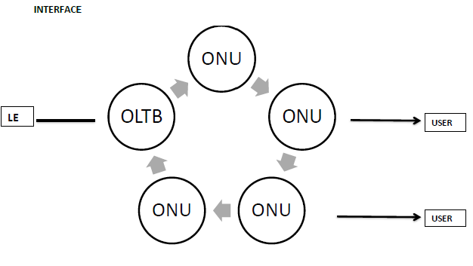

A ring network is a network topology in which each node connects to exactly two other nodes, forming a single continuous pathway for signals through each node - a ring. Data travel from node to node, with each node along the way handling every packet.
Because a ring topology provides only one pathway between any two nodes, ring networks may be disrupted by the failure of a single link. A node failure or cable break might isolate every node attached to the ring. In response, some ring networks add a "counter-rotating ring" (C-Ring) to form a redundant topology: in the event of a break, data are wrapped back onto the complementary ring before reaching the end of the cable, maintaining a path to every node along the resulting C-Ring. Such "dual ring" networks include Spatial Reuse Protocol, Fiber Distributed Data Interface (FDDI), and Resilient Packet Ring.

NGN – Next Generation Networks
Circuit Switching is the oldest and most commonly used switching technique used in telephony. However there are serious drawbacks of circuit switching such as:
- Bandwidth inefficiency
- Difficult to maintain
- Connection set-up delay
To address the above problems, Packet switching came into use. A packet switched network does not require a dedicated path. The packets can follow different routes; hence utilize the bandwidth more efficiently.
NGN (Next Generation Networks) was developed as a packet switching method to transport Voice, Video, and Data using a single network. Some advantages of a NGN network are given below.
- Better Bandwidth utility
- Voice, Video, Data on a single network
- Easy management from a single location
- Reliability i.e. lost packets can easily be detected and be requested again.
- Resilience i.e. if one network link fails, an alternate link can be used
PTCL uses the Huawei C5 NGN network. Huawei SoftX3000 cards are used to manage voice, video and data services on the NGN network.
The NGN control layer consists of the following SoftX3000 Boards
- IFMI (IP Forward Module Interface front Board) – Used to send, receive and process IP packets. It has a speed of 32000 bits per second and uses the RS232 serial port interface. Power consumption is 16 W.

- FCCU (Fixed Calling Control Unit front Board) – Used to store bills. It has a memory of 180 mega bits. It is sends all billing information to the Billing Gateway. It reports its alarms to SMUI. It consumes 16 W and uses the RS232 interface

- ALUI (Alarm Unit Interface front Board) – This board directly communicates with the SMUI. Gives warning when temperature exceeds a certain threshold and monitors power consumption from rectifiers. It has a red led to indicate a fault or temperature rise. The board uses the RS232 interface.

- MRCA (Media Resource Control Access front Board) – This board is a media server. It can store, play and analyze audio files. It also generates ring back tones and is used in video conferencing. It uses the RS232 interface.

- MRIA (Media Resource Interface Back Board) – This is the back board of MRCA.

- UPWR (Universal Power Board) – This board supplies power to all the other boards. It has an input of -36V to -76V. Its output current is 50, 40, 8, and 4 amperes and -5, +4, + 3, +12, -12 volts. The board consumes 20 W.

- UAC (Universal access control unit front board) – Responsible for call control and processing of H.248 and SIP protocols. It has a memory of 119 Mbits. It reports its alarms to SMUI and has a power consumption of 16 W. It uses the RS232, MSGI and BSGI interface.

- AGCU (Access Gateway Control Unit front Board) – The board process SIP and H.248 protocols. It generates bills which are sent to the Billing Gateway. It has a memory of 180Mbits.

- SMUI (System Management User Interface front Board) – This board stores system programs and data. It also controls and manages all other boards. It is responsible for all the management.

- SIUI (System Interface unit) – Back board of SMUI. It has two serial ports: RS232 and RS422.

- BSGI (Broadband Gateway Signalling Interface front Board) – This board process internet packet received from the IFMI. It can use the following protocols: H.248, MTP, M3UA, and IUA. It uses the RS232 interface and sends its alarms to the SMUI. It can extract packets at a rate of 1800 packets per second.

- MSGI (Multimedia Singling Gateway Interface front Board) – This board works in parts and can extract 1000 packets per second. It uses the following protocols: TCP, SIP, and H.232.

- HSCI (Hot Swap Control Interface Back board) – This board provides shared resources bus. It reports to the SMUI. It has 6 fast Ethernet external interfaces.

- CBDI (Central Database board Interface front Board) – This board provides call locations i.e. from where call is originating from. This board works in pairs and it can allocate 9000 subscribers per second

The SoftX3000 switches are compatible with the HCTE (High Capacity Transit Exchange). It can perform PSTN signalling such as SS7. Other protocols used by the SoftX3000 system are: SigTran, MGCP, H.248, H.232, SIP and ISUP.
Currently there are four pairs of NGN centers in Pakistan working in active and standby modes. They are given below:
- KPK and Islamabad Region:
- Rawalpindi Active
- Peshawar Standby

- Lahore Region:
- Lahore Active
- Standby also in Lahore

- Punjab Region:
- Faisalabad Active
- Gujranwala Standby

- Sindh and Baluchistan
- Karachi Active
- Hyderabad Standby
The diagram below shows some of the important protocols involved in a NGN.
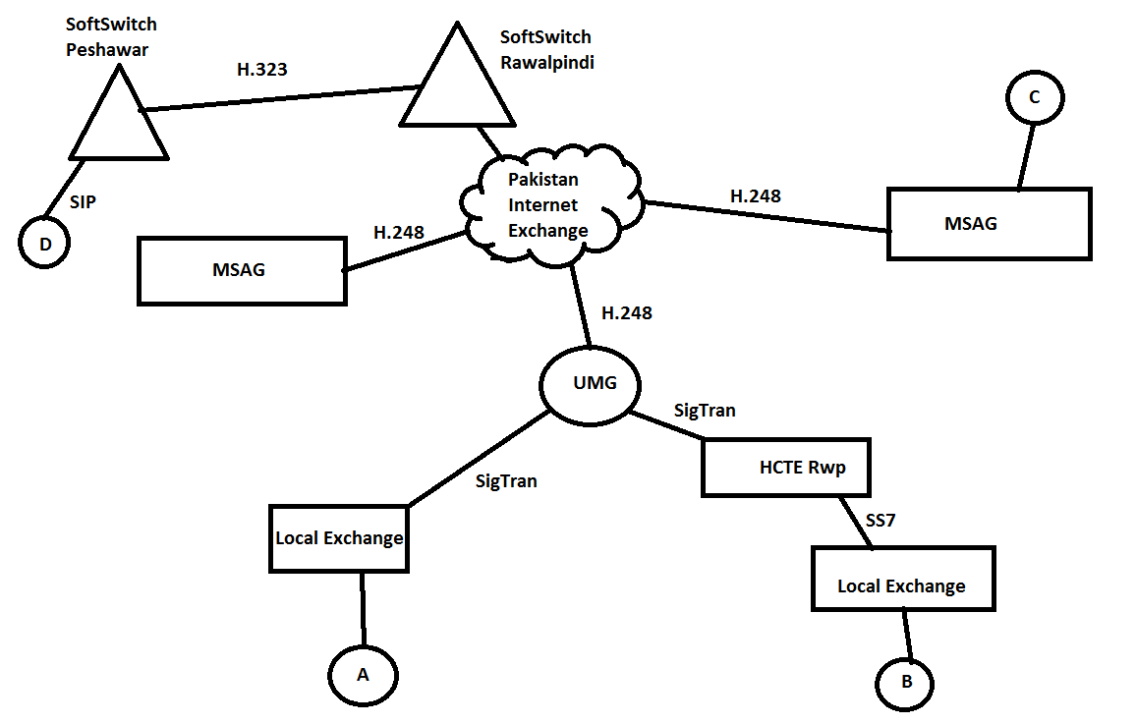

2.3Switching

Technical & Operational Network
Pakistan telecommunication corporation under the act of 1996, Pakistan Telecommunication Authority (PTA) issued a license to Pakistan Telecommunication Company Limited for the provision of telecom services within Pakistan to private sector and the general public as the Federal Government may determine and during the exclusivity period of the Pakistan
Telecommunication Company Limited (PTCL) specified in above-mentioned Act. PTCL has
25 years license to provide telecom services in Pakistan with Stake in the Company with about 62% equity. PTCL has largest network and huge infrastructure for it’s more than 4,405,161 users as on (Mar, 2008).

Switching Technology
There are 7 different kinds of switching technologies currently operational in PTCL network.
- Alcatel
- Siemens
- NEC
- Ericson
- Huawei
- J.S telecom
- ZTE
- With these different switching technologies PTCL is running its huge network and providing different communication facilities to its customers.

2.3.1 Modes of Switching
There are two modes of switching.
- Circuit Switching
- Packet Switching
Circuit switching includes mobile services. It is not reliable as compared to packet switching. Packet switching includes mail via internet, mobile messages etc. It is reliable mode of switching.

PTCL Corporate Services
- DXX
- Non DXX
- ISDN/PRI
- ISDN/BRI
- E1/E3 Connectivity
- MPLS
- EDSLBDSL
- PIE Connectivity
- Web Browser
- Tele presence
- DSR links
Launch Of IN Platform
- To augment the capacity and introduce additional value added services a new Intelligent
Network (IN) Platform was launched in October 2003.This platform has higher capacity
for prepaid calling cards and provision for introduction of new services.
- To further support the launch of new services the optical fiber junction access network
has been in implementation phase. This system further supports the upcoming project of PTCL WLL (wireless local loop), Broad Band Services & IPTV. Network Operation Center (NOC) (Pakistan Telecommunication Company Limited, Oct-Dec 2008, pp. 21-22)
Pakistan Telecommunication Company Limited (PTCL) is a prime provider of telecom voice and data services within Pakistan. As Part of its ongoing infrastructure development, PTCL has embarked on a major investment program in a Network Operations Center (NOC).

Fig. NOC application launched

The purpose of NOC is:
ü To control, monitor and manage the entire PTCL Network
ü To enhance and optimize Network Management through a transparent and centralized platform
ü To create a highly available, adaptable and fault resilient network that can meet the market demand and provide customer satisfaction
Due to the absence of a NOC, PTCL currently faces serious operational challenges:
ü Since there is no centralized network management, fault resolution is ad hoc and inefficient, service restoration takes a long time
ü There is no mechanism for root cause analysis
Through the NOC PTCL have been able to address these issues with:
ü A complete convergence of entire Network on a single platform
ü Proactive identification and resolution of faults through:
§ Real-time Network Monitoring & status visibility.
ü PTCL have been able to increase network availability through:
§ Enhanced Quality of Service and centralized performance statistics and reporting mechanism.
ü Increased Accountability and Transparency
§ Through escalation policies, work orders and maintenance of secure
activity logs

2.3.2 NOC in PTCL
The main NOC is located in the CDDT Building, Islamabad. There are 3 regional NOCs
in Lahore, RWP and Karachi respectively. Disaster Recovery shall be done in Karachi.

Network Domains that have been integrated into NOC:
WLL, IN, Signaling, TDM/, Switching, OFAN, TXM, DXX, PIE, NGN and
Triple Play

Fiber Cut Scenario
On average PTCL experience hundreds of fiber-cuts in a month. As a result PTCL have automated the root cause analysis process for this scenario:
When the system detects a fiber cut a siren goes off, cable cut blinks on the screen and hundreds of critical alarms pop up on the screen, the correlation rule kicks in and the alarms are associated and consolidated into a single root cause alarm. A TT is automatically generated identifying the affected cable section between two NEs.
An automated notification is dispatched to the responsible coordinator via time stamped SMS and EMAIL. The coordinator then issues a work order for fault resolution. IOf the fault is not resolved, verified and closed within a stipulated time frame, the escalation process is triggered and senior management is notified with an SMS and email for appropriate action.
Complete visibility of the network, intelligent root cause analysis and defined SOPs for work order dispatching and escalation are the core tools that shall allow the NOC to provide a robust network making PTCL a landmark of excellence in the world of telecom

2.4 OFS – Optical Fiber Systems
Most copper wires are now being replaced with optical fiber wires. There are many advantages associated with optical fiber, such as a very high bandwidth. Theoretically an optical fiber channel has infinite bandwidth. Optical fiber systems are more secure than copper wires. Other advantages include noise immunity, low cost, easy installation, light weight, and very good signal transmission quality.
Disadvantages of optical fiber are the wires fragility, and harmful effects to the human eye.

2.4.1 Optical fiber Basics
Optical fiber works by converting electrical signals into light of specific wavelengths. The light is then transported through a special cable.
The cable consists of a core, cladding, and a buffer coating. The core is the innermost region through which light is transported. Cladding is used to prevent the light from leaking. It internally reflects any light coming out of the cable. The picture below shows a basic structure of an optical fiber cable.
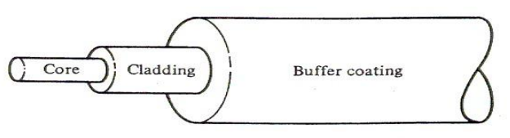

The core of the cable has a low refractive index compared to the cladding. Light is reflected in the core at a specific angle. Due to the refractive index, the light will internally reflect and travel through the cable as shown below.
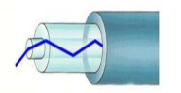
A basic transmission optical transmission system consists of a transmitter which converts electrical signals into light, an optical fiber channel, and a receiver which detects light and converts it into electrical signals. This is shown below.
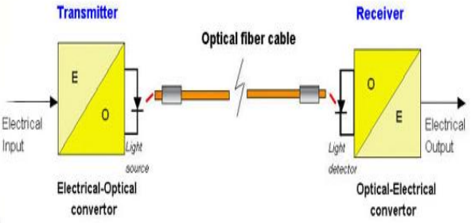
The following bands are used in optical fiber systems:
Band | Wavelength in nm
O | 1,260 – 1,360 | Original
E | 1,360 – 1,460 | Extended
S | 1,460 – 1,530 | Short wavelength
C | 1,530 – 1,565 | Conventional
L | 1,565 – 1,625 | Long wavelength
U | 1,625 – 1,675 | Ultra long wavelength

The following types of networks can be established using optical fiber:
- Point – to – point Network


- Point-to-Multipoint Network
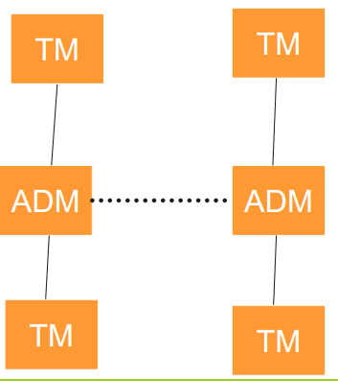
- Ring Network
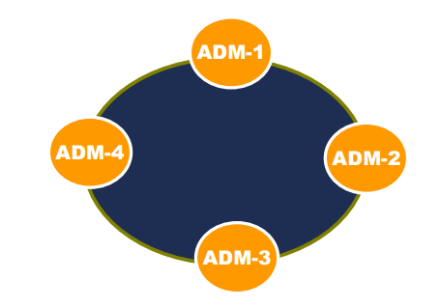
- Mesh Network
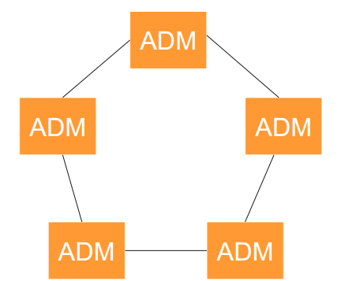
- Composite network
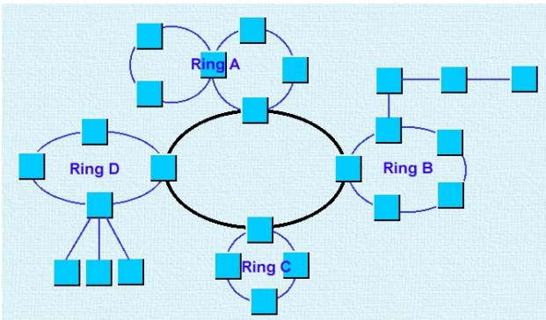

2.4.2 Synchronous Digital Hierarchy
SDH are the most common multiplexing protocols used to transmit digital data over a fiber optic channel. Before SDH, PDH was commonly used; however there were some limitations in PDH, which are given below.
- Different standards
- Complex multiplexing structure
- Synchronization issues
- Weak monitoring
- Low data rates
To address these limitations, SDH protocols were developed. The advantages of SDH are:
- High Data rates
- Easy to interconnect different systems
- Compatible with PDH signals
- Reduced network equipment
- Reliability
- Synchronization
The following rates are available in SDH:
- STM-1: 155.52 Mbps
- STM-4: 622.08 Mbps
- STM-16: 2.488.32 Gbps
- STM-64: 9.95 Gbps
- STM-256: 40 Gbps

Optical Switch Nodes (OSN)
The OSN3500 boards are used in the OFS department of PTCL. The features of the OSN3500 are:
- Service level agreement (SLA)
- Topology automatic discovery function
- Automatic end-to-end service configuration
- Support mesh networking and protection
- Traffic engineering
- Supports RPR
The boards have the following LED indicators:
- Green: Indicates power
- Yellow: Indicates a minor alarm. It is usually ignored
- Orange: Indicates a major alarm. It is often ignored
- Red: Indicates a critical alarm. Immediate action is taken
Transmission and RTR (Rawalpindi Technical Region)
The four main layers, for transmission purposes, of PTCL are discuss below

Subscribers are connected to PTCL through an access layers. For example DSLAM (Digital subscriber line access multiplexer) connects users to a local TDM exchange through a DC (Distribution cabinet) and DP (Distribution panel). The DSLAM is also connected to the PIE (Pakistan internet exchange).

However, DSLAMS are now being replaced with MSAGS (Multiservice access gateways). MSAGS are used in Packet switching, and are directly connected to an IP cloud. FTTH (Fiber to the home) is also a common technology, used to connect subscribers to the service provider.

Communication between exchanges is done through E1’s. a single E1 can transfer data at a rate of 2 Mbits/s. An E1 has 32 channels, however only 30 channels are used for data communication. One channel is used for signaling, and one is used for synchronization. A single E1 line has a data rate of 64 Kbits/s.

The internet network in Pakistan consists of core routers and border routers. The main core routers are located in Karachi, Lahore, Islamabad, and Rawalpindi. The Karachi core router is connected to an international submarine cable SEMEWE4 (South East Middle East Western Europe 4). Users are not directly connected to the core router of security reasons. Each core router is connected to many edge routers, which are connected to exchanges. This network configuration forms the Pakistan Internet Exchange.

The following are used at transmission layer:

- SDH: Synchronous Digital Hierarchy

- ADM

- WDM: Wavelength Division Multiplexing

- PTN: Packet Transport Network.

OSI Model
A network maybe very large making it difficult to study as a whole, there for it is usually divided into seven OSI (Open System Interconnection) layers. Every layer depends on the layer under it.
The seven layers are:
- Application

- Presentation

- Session

- Transport

- Network

- Data link

- Physical

Physical layers include the physical devices used to form the network, for example, connectors, copper wires, fiber optics.
In the Data link layers, many nodes are connected to form a single network. Not all nodes are connected at all the time, but switches are used to connect two different nodes when required. Data is transmitted between nodes as packets. A packet consists of two parts: The header and Payload. Payload is the actual data that has to be transported. Header is the destination address. Each node in layer two has a unique MAC address. Ethernet is a layer 2 device.
The Network layers consist of routers. Routers give direction to packets. Many networks are connected through routers.
Transmission layer is responsible for the transmission of Packets. UDP and TCP are protocols belonging to this layer. Ports are also assigned at this layer, e.g. ports for video data, voice data
Session layer is responsible for signaling and maintain connection. There are many session protocols, such as the SIP (session initiation protocol).
In the presentation layer, encoded data is decoded. Data is usually encoded for security reasons. In these layers, data is also checked for errors.
- INTERNSHIP TASKS
I was assigned a task in the NGN department during the first week of the internship. The task was to update the existing record of wire colours of ADMs, which are used for E1’s. E1’s are a way to transfer data and signaling between two different exchanges. Every E1 has 32 channels. 30 channels are for voice data, one is for synchronization and one is for timing. Each voice channel can carry data at a maximum rate of 64kbits/s. Voice connections are made directly between exchanges, however signalling is routed through STP’s (service transfer points) for better efficiency and to save E1’s. Each E1 can provide services up to 4096 user through time division multiplexing. There were many wire colours i.e. Red, green, blue, yellow, grey, white, black, pink, orange. Some wires were also multicolour. There were three groups, with each group consisting of two interns, to complete the task. Normally one group member was responsible for checking the wire color and the other was responsible for writing the color down on a notebook. Writing down the colors of the wires in the notebook of all the E1’s took about four days. After this, all the data was entered into a Microsoft excel spreadsheet. The new data was compared with the previous data and any differences between the colors were noted.
I was also asked to introduce new interns to basic concepts such as difference between circuit and packet switching, and the seven OSI layers in the NGN-HCTE department.
Analysis
During the internship period, I observed that there were not enough engineers to train internees. Overall there seemed to be a shortage of staff in the NGN and OFS department. The engineers did not have enough time to teach internees. Also, interns were not encouraged to learn the hardware and software used by the different departments. There was no telecom equipment only for training purposes. Only lectures were given, with very little practice work. Not every internee was assigned a task.

4. SWOT Analysis of PTCL:
Strengths:
- Attributes of the organization that are helpful in achieving the objectives.
    - PTCL Strengths Oldest Telecommunication Company of Pakistan founded in 1947.
- The largest landline network of Pakistan.
    - Strong international brand names.
    - Strong financial position
    - Competent and Skillful Human Resources in few specialized fields.
    - PTCL is offering multiple services which includes Telephone, Internet and T.V.
    - PTCL can be used as a backup network if the mobile networks are down due to any reason.
    - PTCL maintain the records of customers in an organize way with the principle of privacy.
    - All the telecommunication companies operating in Pakistan directly or indirectly dependent upon PTCL network.
    - It has been offering Internet DSL connection to the customers with students’ package offer.
    - It offers low rates for the national calls etc., as compared to mobile networks
Weaknesses:
    - Quality of Service; offered to the Customer is very poor and in-efficient, specially the Internet service.
    - Lack of technical staff in DSL technical support.
    - Poor organizational structure.
    - No clear strategic direction.
    - No research and development programs.
    - Functional units are not well organized.
    - Weak marketing of new services.
- Bad debts due to non-payments of bills.
- Low revenue per user.
- Political intervention in decision making.
- Low rate of customer retention.
- Extra employee overhead due to over-hiring.
- Very low employee morale.
- V-wireless coverage and service is feeble.
Opportunities:
- Huge market size to Increase market share.
- Development of new, innovative and customized products (Increase in company product lines)
- Re-structuring of organizational hierarchy (Proper planning and implementation is required, to Improve overall services).
- Adopt latest technologies.
- Making technology accessible to all (e.g. broadband).
- Hire competent marketers and adopt aggressive marketing that is required to promote offered services and give tough time to competitors.
- Improvement in customer services.
- Joint ventures with other telecommunication companies for introducing new services.
- Hire technical staff in specific areas e.g. for DSL issues in order to increase customer satisfaction
Threats:
- Strong competition from telecommunication companies.
- New players in the industry.
- Inconsistent and Adhoc decisions by Company management.
- Security and fraud issues.
- Cybercrimes percentage is increasing.
- Political instability.
- Inflation in the country, may increase the cost of services which will finally transferred to customers.
- Rapid raise in Government taxes.
- Recession in economy.

5. FINDINGS AND RECOMMENDATIONS

In this chapter, we are going to discuss the findings and my view of recommendations which we faced and thought during the internship. These findings and recommendations will help the organization to serve the customers in a better way and will enhance their capabilities of performing earning and they will get the high value than those upcoming competitors of it.

5.1 Findings
Below are some of the observations which we did during my internship duration. We mention it here for the purpose to enhance the capabilities of the organization of my Area if these are considered by the managers. They will also have an edge on the upcoming competitors of them and will not let them loose their potential customers.
- No proper theory references on related topic for courses.
- The employees were not trained enough and were not having enough knowledge about the work they were performing.
- Less educated staff reduces the performance growth of the department in general and of the organization as a whole.
- Lack of time Punctuality of workers and employees.
- No full co-ordination with the other departments.
- No proper procedure of installing new connections due to which the complaints increase and also some customers lose their confidence in the Broadband connections.
- Internees were performing all the travel.
- Lack of computer knowledge of well designated employees.

5.2 Recommendations
The number of trainee engineers should be increased by increasing the number of positions available through the one year paid internship program. This way there will be enough engineers to train summer internees. Internees should be given basic hands on training on the different hardware and software used by the departments. Also tasks, such as making databases, should be assigned to every internee, not just a few. And other recommendations are discuss below
- No doubt P.T.C.L having the monopoly in providing the Land-Line Telephone connection in Pakistan and its playing its role magnificently. In current scenario P.T.C.L has increases its Revenue quite dramatically and probably that as soon as this organization has become privatized it will flourish its revenue in better manner.
- PTCL should immediately change its Finance upper level of hierarchy and should stream line in the good manner.
- PTCL should also encourage the Billing On line system that each and every customer should have to pay his/her bill on line basis..
- The image of PTCL being leading Telecom providing is not good in the eyes of common customer especially there are lot of complaints about the including the bogus local calls in the monthly bills of various customers. PTCL should also provide the detail of local calls made from any Land Line Number which would be provided in Micro level to the customer.
- Should be decreased the over number of employees.
- Should be developing the training and development process of every employee.

